**Comparative analysis on critical success factors on branding a university**

**Master Thesis**

**Hof University**

**Department of Business Administration**

**German Indian Management Studies**

**Submitted to Submitted by**

**Prof. Dr. Stefan Wengler Meher ChaitanyaKanuri**

**Prof. Dr. Georg Fischer 00714614**

**Alfons-Goppel-Platz 1 Gandhi Nagar 2nd street**

**95028- Hof 631502-Kanchipuram, India**

**Hof, October 19th 2015**

Executive Summary

Indian education system is one amongst the largest education providers in the world along with the USA and China. Indian higher education is undergoing a drastic change. This change is new and is also very important for the development of the country. The context of the problem is to understand whether the universities in India are able to cope up to the change and meet the demands of the students and survive in the education sector.

This paper deals with understanding the whole higher education system in India and also to focus on the critical success factors of a successful university in south India and to compare it with a normally performing university. So based on the objectives, two universities from south India have been selected and comparison on their branding strategies are observed. The respective data is obtained from survey and personal interview with students of the selected universities.

The paper also give recommendation based on observations done by evaluating marketing mix, student’s expectations vs. reality and promises given vs. reality by the two selected universities so that the underperforming university can perform better and make profit.

Table of contents

Executive Summary iv

List of Figures vii

List of Tables viii

List of Abbreviations ix

Preface xi

1 Introduction 1

1.1 Context of the problem 3

1.2 Research objective 4

1.3 Methodology 4

2 Indian higher education system 5

2.1 Classification of higher education system 5

2.2 Role of Government 9

2.3 Realities in the sector 12

2.4 Challenges faced by the sector 19

3 Analysis of selected universities 24

3.1 Introduction to selected universities 24

3.2 Courses offered (Product) 28

3.3 Fee structure (Price) 30

3.4 Location (Place) 31

3.5 Promotion 33

4 Comparative analysis of Branding 36

4.1 Branding of universities 36

4.2 Promises made by the universities 37

4.3 Expectations of the students 38

4.4 Reality and Gap analysis 40

4.4.1 Comparison of marketing mix between the two selected universities 40

4.4.2 Factors influencing choice of university 42

4.4.3 Promises vs Reality 43

4.4.4 Students expectation vs Reality 44

4.4.5 Factors influencing decision to pay capitation 46

4.5 Critical success factors (SWOT) 47

5 Recommendations (Action plan) 48

6 Conclusion 49

**Bibliography**

**Appendix**

List of Figures

Figure 1: Structure of Indian education system 2

Figure 2: Classification of Indian higher education system (regulated) 5

Figure 3: Indian education sector regulatory heat map 8

Figure 4: Growth in universities, colleges and student enrolments (2012) 13

Figure 5: Types of colleges in India 14

Figure 6: Higher education institutions in India (2013) 15

Figure 7: Student enrolment through regular mode at various levels 15

Figure 8: Student enrolment in top ten streams 16

Figure 9: Key indicators Tamil Nadu 17

Figure 10: Division of universities in Tamil Nadu 17

Figure 11: Student enrolment ratio in Tamil Nadu through regular mode at various level 18

Figure 12: The changing phase of Indian Higher education 23

Figure 13: Logo of SCSVMV University 24

Figure 14: Logo of VIT University 27

Figure 15: Paper advertisement of SCSVMV University 33

Figure 16: Paper advertisement of VIT University 34

Figure 17: Paper advertisement of VIT University 35

List of Tables

Table 1: Key challenges in the education field 19

Table 2: Fee structure of SCSVMV University 30

Table 3: Fee structure of VIT University 30

Table 4: Branding of universities (SCSVMV and VIT) 37

Table 5: Promises made by both the universities 38

Table 6: Expectation of students 39

Table 7: Comparison of marketing mix between the universities 41

Table 8: Factors influencing choice of university (ranks) 42

Table 9: University 1 promises 43

Table 10: University 2 promises 44

Table 11: Expectation vs. reality in university 45

Table 12: Expectation vs. reality in university 2 46

List of Abbreviations

USA – United States of America

FICCI – Federation of Indian Chambers of Commerce and Industry

E & Y – Ernst and Young

CII – Confederation of Indian Industries

PWC – Price Waterhouse Coopers

UGC – University Grants Commission

MHRD – Ministry of Human Resource Development

IIT – Indian Institute of Technology

IIM – Indian Institute of Management

IISC – Indian Institute of Science

UNESCO – United Nations Educational, Scientific and Cultural Organization

AICTE – All India Council for Technical Education

DTE – Directorate of Technical Education

MCI – Medical Council of India

NCTE – National Council for Teacher Education

DCI – Dental Council of India

PCI – Pharmacy Council of India

INC – Indian Nursing Council

BCI – Bar Council of India

CCH – Central Council of Homeopathy

CCIM – Central Council for Indian Medicine

GER – Gross Enrolment Ration

CAGR – Compound Annual Growth Rate

PG – Post Graduate

UG – Under Graduate

B.E – Bachelor of Engineering

B.TECH – Bachelor of Technology

M.E – Master of Engineering

RUSA – RashtriyaUchchatarShikshaAbhiyan

NSDC – National Skill Development Corporation

HEI – Higher Education Institutions

NASSCOM – National Association of Software and Services Companies

NAAC – National Assessment and Accreditation Council

SCSVMV – Sri ChandrasekharendraSaraswathiViswaMahaVidyalaya

VIT – Vellore Institute of Technology

Ph.D. – Doctor of Philosophy

VITEEE – VIT Engineering Entrance Examination

NSS – National Service Scheme

Preface

Knowledge is evergreen and to keep it green, we need education. Education in India is one of the largest markets and is growing very fast. My father and mother who are teachers have always been an inspiration for me also to become a teacher in future. This research on understanding the whole concept of student attraction, branding and promotional strategies has helped me understand the education system much better.

The reason behind choosing SCSVMV is because I studied my bachelor’s degree there and the reason behind choosing VIT university is because of my passion to to be a part of it in future as a teacher.

I would like to personally thank Prof. Dr. K.P.V Ramana Kumar, Dean Faculty of Management Studies who helped me with internal data of SCSVMV University which helped me with my research analysis.

I would also like to thank all my friends and family members who have been a great support to me and help me in finishing this research.

1 Introduction

India, with more than a billion residents, has one of the largest education systems in the world. In ancient times “Gururkul”[1] system of education was followed. It was a simple concept where children used to learn under great scholars but they had to stay away from their parents. It is unlike the modern boarding schools but a school that teaches moral values and imparts spiritual knowledge. Children learn to lead a simple life with little or no bad habits. Their memory gains great momentum to learn things. With the friendly environment and active teachers they were able to become good citizens of the nation and supporting pillars of their family.

TheseGurukula’swere traditional Hindu residential schools of learning; typically it was a teacher's house or a monastery. The Gurukula’s usually existed in forests. Education was tremendously important for the society and was given to the 3 upper classes, namely Brahmin’s(priests), Kshatriya’s(warriors) and Vaishya’s(businessmen). Sincethe occupations were based upon castes, children were initiated into the secrets of their traditional vocations from a very early age.

Admission into a Gurukula was not easy. A student had to convince the Guru that he had the required intelligence, desire, determination and qualities to pursue the studies. He had to serve him for a long time before he was admitted into the school and initiated into the subjects. Students in the Gurukula were subjected to rigorous discipline. Sometimes when the Guru traveled to some other place the students had to accompany him. They had to live in a very austere environment. They practiced yoga, meditation and Vedic hymns in Sanskrit language under the supervision of the master. They performed many menial jobs for the master's household. On some specific occasions they had to undergo fasting as a necessary means of purification and mastery of the body and mind.

Hinduism recognizes the importance of knowledge in the spiritual progress of man. Education was free, but students from the rich families paid Gurudakshina(master’s fees), a voluntary contribution after the completion of their studies. Teachers at Gurukula imparted knowledge of Scriptures, Religion, Literature, Warfare, Philosophy, Statecraft, Medicine, Astrology and History.

This all came to an end under the British rule from 1700’s until 1947, India’s education policies[2] reinforced the pre-existing elitist tendencies, tying entrance and advancement in government service to academic education. The curriculum was confined to “modern” subjects such as Science and Mathematics, and subjects like Metaphysics and Philosophy were considered unnecessary. Teaching was confined to classrooms and the link with nature was broken, as also the close relationship between the teacher and the student.

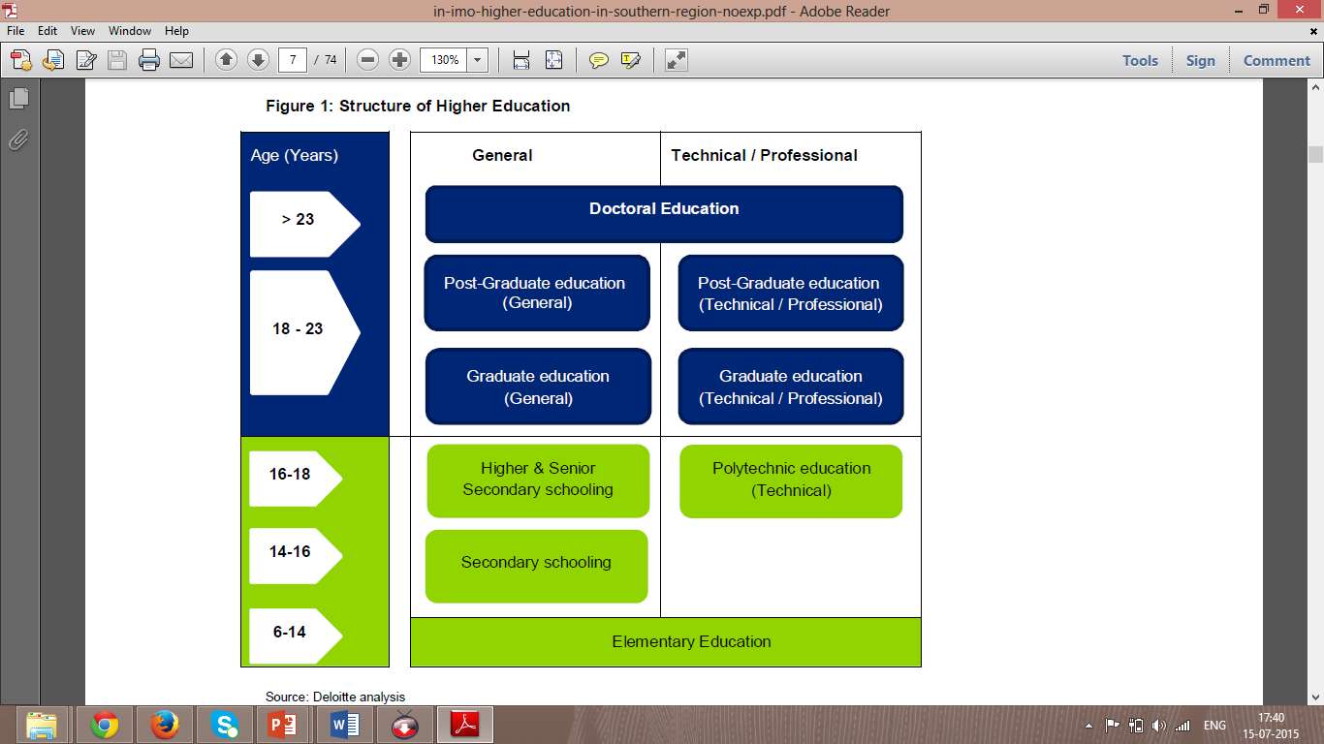The present education system is classified into three categories namely primary education, secondary education and higher education.

Figure 1: Structure of Indian education system[3]

Primary education or elementary education often in [primary school](https://en.wikipedia.org/wiki/Primary_school) or [elementary school](https://en.wikipedia.org/wiki/Primary_school) is typically the first stage of [compulsory education](https://en.wikipedia.org/wiki/Compulsory_education), coming between [early childhood education](https://en.wikipedia.org/wiki/Early_childhood_education) and [secondary education](https://en.wikipedia.org/wiki/Secondary_education).The students will be between the age of 6 to 14 when they undergo primary education and in India it is made compulsory for all the children to have primary education.

Classes from 9 to 12 are the secondary education period where the students start choosing subjects between commerce, computers, biology etc. to pursue in the same field in future. After class 10 the student can choose to pursue vocational training of his choice. After secondary education orclass 12 a student can opt for higher education (study arts and science, medicine, engineering or any vocation). The paper deals with higher education sector majorly focusing the field of Engineering.

1.1 Context of the problem

Indian higher education is going through an epochal change considering the changes in emerging new realities and new possibilities dealing with the issues of expansion and excellence. Indian higher education system is broadly classified into the scholarly pursuits/achievements in universities/colleges and workforce requirements. In spite of having well defined statutory bodies at the central and the state levels, the Indian private education providers and the industry including the foreign education providers have not been able to achieve the ambitious targets set for the nation. There has been huge development in the last decade in the emergence of Indian private education providers. In the recent past there has been good increase in the number of students enrolled in higher education and India is the third largest in the enrolment of students in Higher education after china and USA. 90% of the institutions in India are private and they offer many courses in the field of science, engineering, technology and management. The current scenario sees that there is a supply demand mismatch in the private education providers of Engineering. Some universities are able to make good profits and expand but some universities are not able to do so. There is a gap between what is said by the universities and what is given (expectation vs. reality). There is huge scope for higher education in India but the present situation is that there are not many students opting for it. The paper majorly focuses on the changing scenario which brings us to a question in the context of mandatory changes how an institute of higher education in private sector should brand itself to stay relevant in the market and what could be the possible reasons behind investments by students/parents into selected private deemed universities for securing admission in the field of engineering studies.[4]

1.2Research objective

To identify the success factors in branding of the selected universities and the critical success factors in becoming a reputed university. Also to understand the opinion of the students on all the activities practiced by the university in creating awareness, attraction and desire to join in a university (Branding) and to understand the opinion of the students on various factors relating to their experience after joining the university verses expectation.

1.3 Methodology

The thesis begins with an introduction to the topic by providing a context to the problem followed by the objectives through which a solution will be suggested. The next part of the thesis consists of the introduction to the Indian education system, its key features, role of the government, problems and the reasons behind it and future scope of the Indian education system. This is followed by the analysis of the selected universities through which the researcher wants to find out from a student’s perspective on how the universities create awareness, attract students and build in the desire into the student to join a particular university. Based on the primary and the secondary data collected a comparative analysis is done and through which the gap between the reality vs. expectation of a student before and after joining the university is found out. Suggestion towards improvement is also given which is the action plan for the selected universities.

2 Indian higher education system

2.1 Classification of higher education system

Indian higher education system[5] is majorly classified into two categories namely 1. Regulated and 2. Non-regulated. The regulated version of the system consists of the institutions which follow guidelines set up by the state or the central government. The non-regulated institutions are private institutions which run for a specific purpose and do not have any specific guidelines to follow from the government.

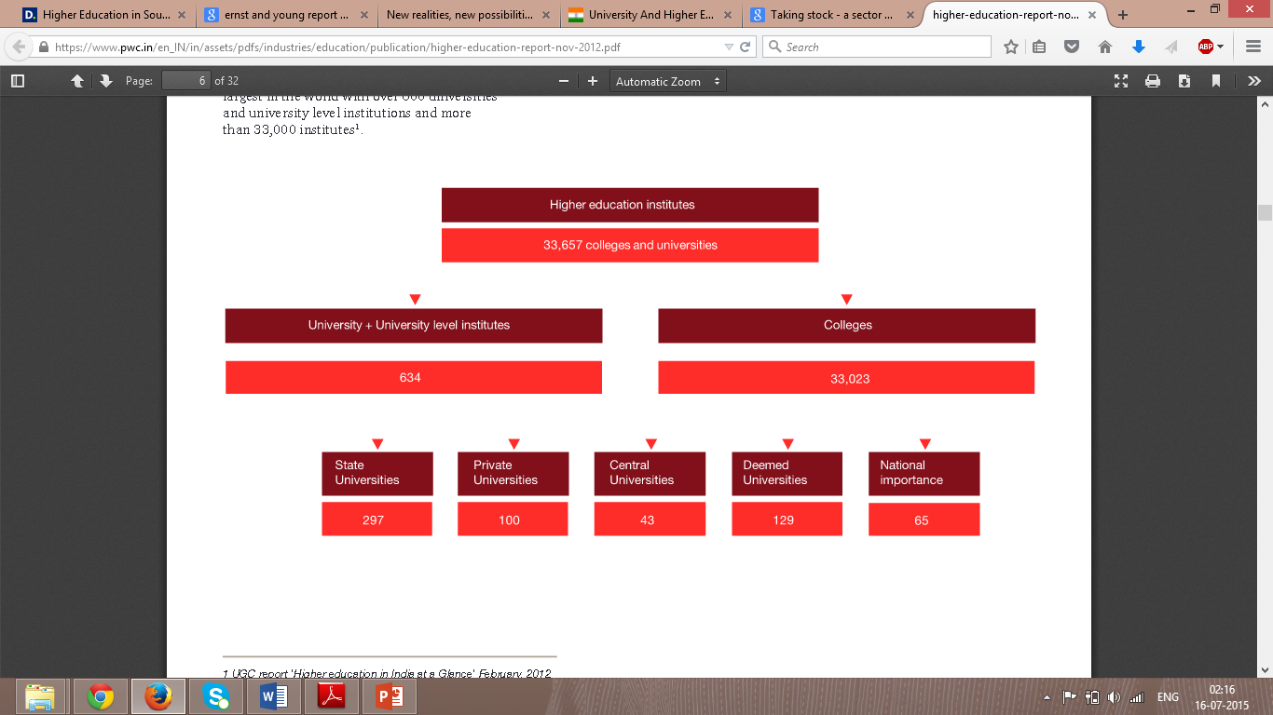

Figure 2: Classification of Indian higher education system (regulated)[6]

**State university[7]:**Universities set up or recognized by an act of the state legislature are known as state universities. State governments are responsible for establishment of state universities and provide plan grants for their development and non-plan grants for their maintenance. The UGC makes budgetary plan allocation for some state universities. As per section 12(B) of the UGC act, state universities established after June 17, 1972 will not be eligible to receive any grant from the central government, UGC, or any organization receiving funds from the government of India, unless the UGC makes an exception. Madras University, Bangalore University, Acharya Nagarjuna University are some examples of state universities.

**Private university[8]:**A private university is an institution of higher learning established through a state or central act by a sponsoring body, such as a society registered under the Societies Registration Act, 1860, or any other corresponding law for the time being in force in a state or a public trust or a company registered under Section 25 of the Companies Act, 1956.

For an institution to be given the status of a private university, the state legislature conferring the status has to pass an act by which the institution will receive the status of a university. Private universities have to be recognized by the UGC so that the degrees awarded by them have to be of any value. Amity University, Lovely Professional University, O.P. Jindal Global University are some examples of this category.

**Central university[9]:**Central universities are set up by an act of Parliament. There are 46 central universities in the country. The President of India is a visitor at all central universities. The University Grants Commission (UGC) is the agency that provides funding for maintenance and development of these universities. Jawaharlal Nehru University, Tezpur University, Central University of Gujarat are some examples of Central universities in India.

**Deemed university[10]:** Institutions of higher learning, which are not universities, are often in recognition of their high caliber of education granted the status of a university. Such institutions are known as deemed to be university, or deemed university.

The status of a deemed university is accorded by the UGC. Section 3 of the UGC Act, provides for the conferring of this status of autonomy granted to high performing institutes and departments of various universities in India. Deemed university status enables not just full autonomy in setting course work and syllabus of those institutes and research centre’s but also allows it to set its own guidelines for the admissions, fees and instruction of the students. As in other universities students are conferred degrees on completion of their program.SCSVMV University, VIT University, Manipal University are examples of Deemed universities.

**Institutes of national importance[11]:**An Institute of National Importance, in India, is defined as one which serves as a pivotal player in developing highly skilled personnel within the specified region of the country/state. Only a chosen few institutes make it to this coveted list and are usually supported by the Government of India or even international institutes to develop centers of excellence in research, academics, and other such elite schools of education. All of the IITs, IIMs, IISc etc. are a part of this category.

**Affiliated colleges[12]:**There are two types of affiliated colleges-government colleges, and privately managed colleges. The colleges offer mostly undergraduate courses, though some of them also have introduced postgraduate courses in selected subjects. Most of the affiliated colleges offer courses in arts, science and commerce. In addition, they also offer technology, management, education and law. The government colleges constitute about 15-20% of the total. They are managed by the State Governments concerned. Approximately 70% of the colleges are established by privately managed trusts or societies. Nearly 33% of these colleges are located in rural areas. However, many of them are non-viable because of low level of enrolment. The management committees of the private colleges are constituted according to the norms laid down by the statutes of the university concerned.

Though established through private initiative, many of them now receive considerable financial support from the concerned State Governments. The power of granting affiliation to a college vests with the respective universities and is exercised in consultation with the State Governments. Like unitary universities, several affiliating universities also have university colleges as well as constituent colleges, which are managed by the university itself also lays down the courses, conducts their examinations and awards the degrees. 

**AutonomousColleges[13]:**Among the affiliated colleges, there is a special category called autonomous colleges. The national Policy of education (1996) had advocated granting autonomy to colleges and also to university departments with the object of bringing about decentralization of academic administration, promoting innovation and ensuring higher standards. An autonomous college enjoys academic freedom to prescribe its own rules of admission, designing of curriculum, mode of conduct of examinations, and introduce innovations in determining the courses of study and evaluation. The affiliating universities accept the methodologies of teaching, evaluation and examination, course curriculum, etc., adopted by these colleges. However, the degrees are awarded by universities and the names of the colleges are mentioned in the diplomas. The renewed effort of the UGC to grant this status to more number of colleges had met with stiff opposition from several universities.

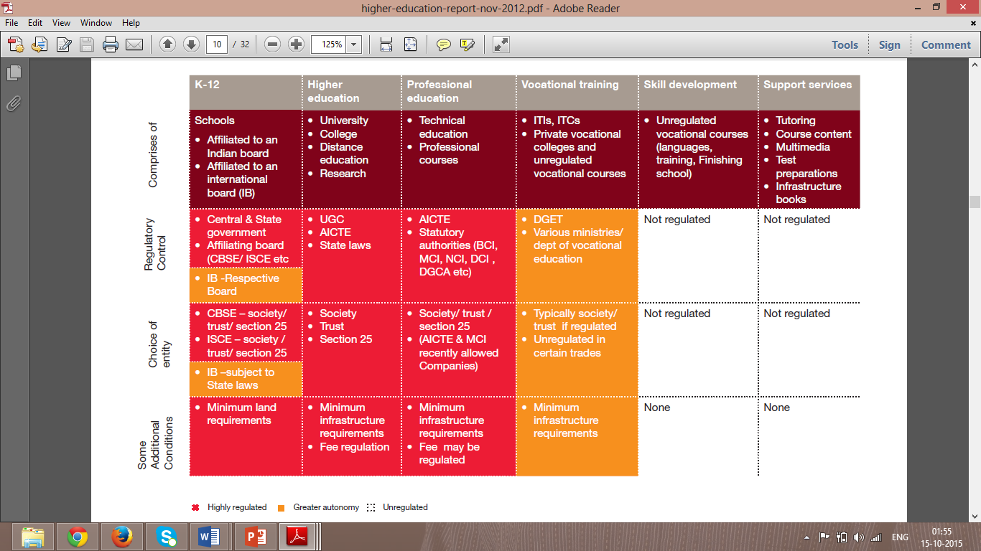**Self-financingColleges:**Among the affiliated colleges are also the self-financing colleges. Some University departments too have introduced self-financing courses. As the name suggests, they survive on the money earned by collecting tuition fees and other levies. Self-financing professional colleges affiliated to universities follow the same curricula and courses as offered by public funded colleges. Self-financing arts and science colleges, also affiliated to universities, prefer to offer, professional or quasi-professional courses such as business administration, bank management, company secretary-ship, biochemistry, microbiology, electronics, catering technology and hotel management, fashion design, computer science, visual communication etc.

Figure 3: Indian education sector regulatory heat map[14]

Education in India has always been regarded as a not-for-profit activity. Currently, only registered societies or trusts and in certain cases, not-for-profit companies registered under Section 25 of the Indian Companies Act (not permitted to distribute dividends) are allowed to establish formal educational institutes. The spirit behind this ideological and legal position has been the belief that education is a charitable enterprise which would be tainted if profit-making is allowed. This may well be the reason for the tax exemptions allowed to educational institutions.

To better understand the dynamics of the Indian education and training sector, the chart above compare the extent and intensity of restrictions that the existing regulations place.

2.2 Role of Government

## Ministry of Human Resource Development (MHRD)[15]:The [Ministry of Human Resource Development (MHRD)](http://www.education.nic.in/) was established in 1985 dissolving the Ministry of Education. The MHRD has two departments: Department of School Education and Literacy and the Department of Higher Education. The Department of School Education & Literacy is responsible for development of school education and literacy in the country and the Department of Higher Education takes care of what is one of the largest Higher Education systems of the world, just after the United States and China. The Ministry’s function is to address the public and private education sector functioning by writing policies, programs, schemes and legislation in coordination with other Ministries for the betterment of people’s education and literacy. Main objectives of MHRD are -

* Formulating the National Policy on Education and to ensure that it is implemented in letter and spirit
* Planned development, including expanding access and improving quality of the educational institutions throughout the country, including in the regions where people do not have easy access to education.
* Paying special attention to disadvantaged groups like the poor, females and the minorities
* Provide financial help in the form of scholarships, loan subsidy, etc. to deserving students from deprived sections of the society.
* Encouraging international cooperation in the field of education, including working closely with the UNESCO and foreign governments as well as Universities, to enhance the educational opportunities in the country.

**University Grants Commission (UGC)[16]:**The UGC, however, was formally established only in November 1956 as a statutory body of the Government of India through an Act of Parliament for the coordination, determination and maintenance of standards of university education in India. In order to ensure effective region-wise coverage throughout the country, the UGC has decentralized its operations by setting up six regional centres at Pune, Hyderabad, Kolkata, Bhopal, Guwahati and Bangalore. The head office of the UGC is located at Bahadur Shah Zafar Marg in New Delhi, with two additional bureaus operating from 35, Feroz Shah Road and the South Campus of University of Delhi as well.

The UGC has the unique distinction of being the only grant-giving agency in the country which has been vested with two responsibilities: that of providing funds and that of coordination, determination and maintenance of standards in institutions of higher education.

The UGC's mandate includes:

* Promoting and coordinating university education.
* Determining and maintaining standards of teaching, examination and research in universities.
* Framing regulations on minimum standards of education.
* Monitoring developments in the field of collegiate and university education; disbursing grants to the universities and colleges.
* Serving as a vital link between the Union and state governments and institutions of higher learning.
* Advising the Central and State governments on the measures necessary for improvement of university education.

**All India Council for Technical Education (AICTE)[17]:** The All India Council for Technical Education (AICTE) is the statutory body and a national-level council for technical education, under [Department of Higher Education](https://en.wikipedia.org/wiki/Department_of_Higher_Education_(India)), [Ministry of Human Resource Development](https://en.wikipedia.org/wiki/Ministry_of_Human_Resource_Development_(India)). It was established in November 1945 first as an advisory body and later on in 1987 given statutory status by an Act of Parliament, AICTE is responsible for proper planning and coordinated development of the [technical education](https://en.wikipedia.org/wiki/Vocational_education) and [management education](https://en.wikipedia.org/wiki/Business_education) system in [India](https://en.wikipedia.org/wiki/India). The AICTE [accredits](https://en.wikipedia.org/wiki/School_accreditation) postgraduate and graduate programs under specific categories at Indian institutions as per its charter.

**National Assessment and Accreditation Council (NAAC):**It is an autonomous body established by the University Grants Commission (UGC) of India to assess and accredit institutions of higher education in the country. It is an outcome of the recommendations of the National Policy in Education (1986) which laid special emphasis on upholding the quality of higher education in India. To address the issues of quality, the National Policy on Education (1986) and the Plan of Action (POA-1992) advocated the establishment of an independent national accreditation body.

Similar to the above mentioned government bodies, there are many other regulatory bodies who govern, fund, coordinate, manage and control the higher education system in India. Directorate of Technical Education (DTE), [Medical Council of India (MCI)](http://examcrazy.com/Education-System/India/Medical-Council-of-India-MCI-Regulatory-Authority.asp), [National Council for Teacher Education (NCTE)](http://examcrazy.com/Education-System/India/National-Council-for-Teacher-Education-NCTE-Regulatory-Authority.asp), [Dental Council of India (DCI)](http://examcrazy.com/Education-System/India/Dentists-Council-of-India-DCI-Regulatory-Authority.asp), [Pharmacy Council of India (PCI)](http://examcrazy.com/Education-System/India/Pharmacy-Council-of-India-PCI-Regulatory-Authority.asp), [Indian Nursing Council (INC)](http://examcrazy.com/Education-System/India/Indian-Nursing-Council-Regulatory-Authority.asp), [Bar Council of India (BCI)](http://examcrazy.com/Education-System/India/Bar-Council-India-Regulatory-Authority.asp), [Central Council of Homeopathy (CCH)](http://examcrazy.com/Education-System/India/Central-Council-of-homeopathy-Regulatory-Authority.asp), [Central Council for Indian Medicine (CCIM)](http://examcrazy.com/Education-System/India/Central-Council-of-Indian-Medicine-Regulatory-Authority.asp) are some examples. Deciding on number of seats to be admitted into the institution, the amount of funds to be provided for the institution, the curricula, the minimum infrastructure required, the licences etc. are the major functions of the above mentioned statutory bodies.

2.3 Realities in the sector

The Indian higher education system has established itself as one of the largest in the world, in terms of number of institutions and student enrolment. Higher education spends in India are currently estimated at 46,200 crores (Indian rupees) and are projected to grow to nearly 150,000 crores (Indian rupees) in the next 10 years, reflecting an average growth rate of 12.8%. Against the backdrop of this high growth, the nature of demand for higher education is witnessing a change. Changing macro-economic trends are influencing the composition and preferences of students, leading to new demand-side realities. These include increasing spends on education, new categories of students, willingness to pay for academic quality, increasing demand for global education and demand for employability-linked education. With substantial participation from the private sector and growing interest from foreign players, supply of higher education has increased substantially.

The Government has also augmented supply through enhanced funding and by setting up new institutes. While the increased supply is a step in the right direction, there is a need to align supply to the changing needs of students. The research highlights how this alignment can be brought about through diversification and collaboration in the higher education space through branding based on product, place, price and promotion. While the Government continues to be the cornerstone of the higher education system, it needs to play a much larger role in facilitating the new possibilities to effectively cater to the emerging demands of students.

Education is in the concurrent list. Over time, while the role and responsibility of the States’ has remained largely unchanged, the Union Government has accepted the larger responsibility of reinforcing the national and integrated character of education, maintaining quality and standards including those of the teaching profession at all levels and the study and monitoring of the educational requirements of the country.

The gross enrolment ratio (GER) in higher education, as per the all India survey on higher education released by MHRD, stands at 18.8%2 but all those who enroll may not pursue studies to get final degrees. A comparison of the growth patterns of the rising number of universities and institutes on the one hand and the increasing student enrolments on the other indicates that the sector has attracted investments from both the public and private sectors. For instance, the number of institutes has nearly doubled from 16,800 to 33,000 at a CAGR of more than 11% between 2004-05 and 2011-12. The student enrolment numbers, during the same period, have also increased from 10.6 million to 16.9 million at a CAGR of 8%. However, despite a significant growth in enrolments, the GER in higher education in India is still lower than the world average (24%), and much lower than that of developed nations (58%). Clearly, there is a long way to go to achieve the GER target set by the MHRD of 30% (by 2020).

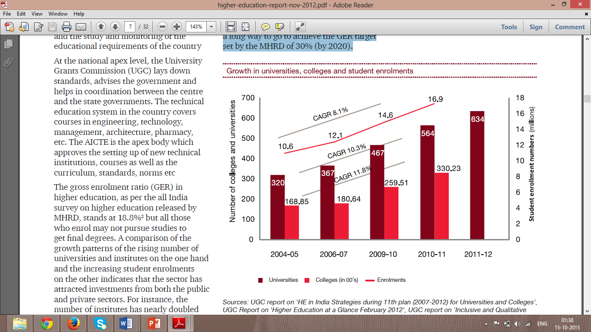Figure 4: Growth in universities, colleges and student enrolments (2012)[18]

Figure 5: Types of colleges in India[19]

There are totally 35,539 colleges in India and the break-up of number of universities in the country on the basis of type of university is shown below. There are a total of 700 universities across the country, with state public universities constituting the highest share (44.5%). The top five states with the highest number of universities include Tamil Nadu (59, 9.2% of total in India), Uttar Pradesh (57, 8.9 %), Andhra Pradesh (47, 7.3%), Rajasthan (45, 7%) and Maharashtra (44, 6.9%). The break-up of the universities by type indicates variance between the top five states as follows: While Tamil Nadu is ranked first in India in terms of private deemed universities (27, 34.2% of total universities in the state), state public universities comprised the biggest share of universities in A.P (31, 10.8%), followed by Karnataka & Tamil Nadu (23, 8%), and Gujarat (22, 7.7%). In Rajasthan, state private universities comprised the highest share of universities (19, 18.1%).

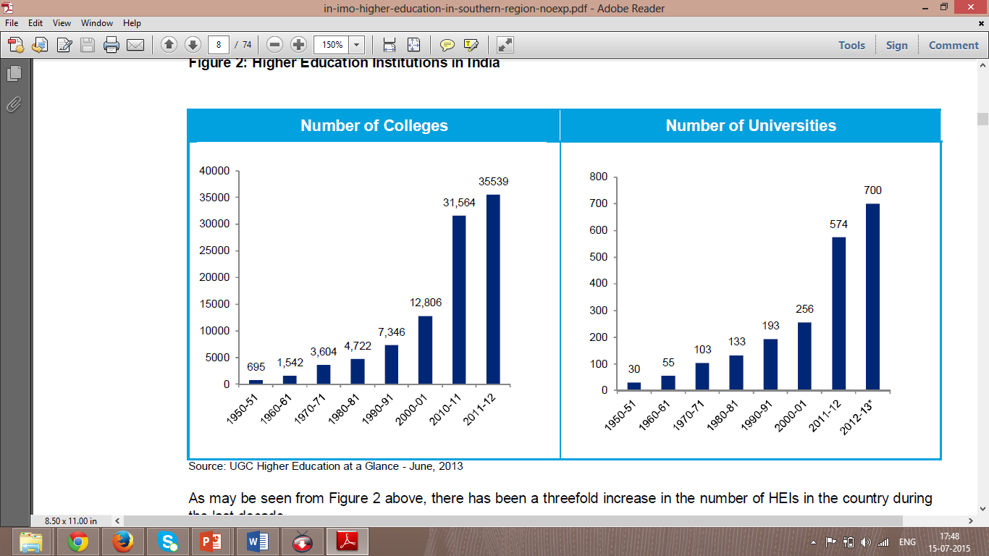

Figure 6: Higher education institutions in India (2013)[20]

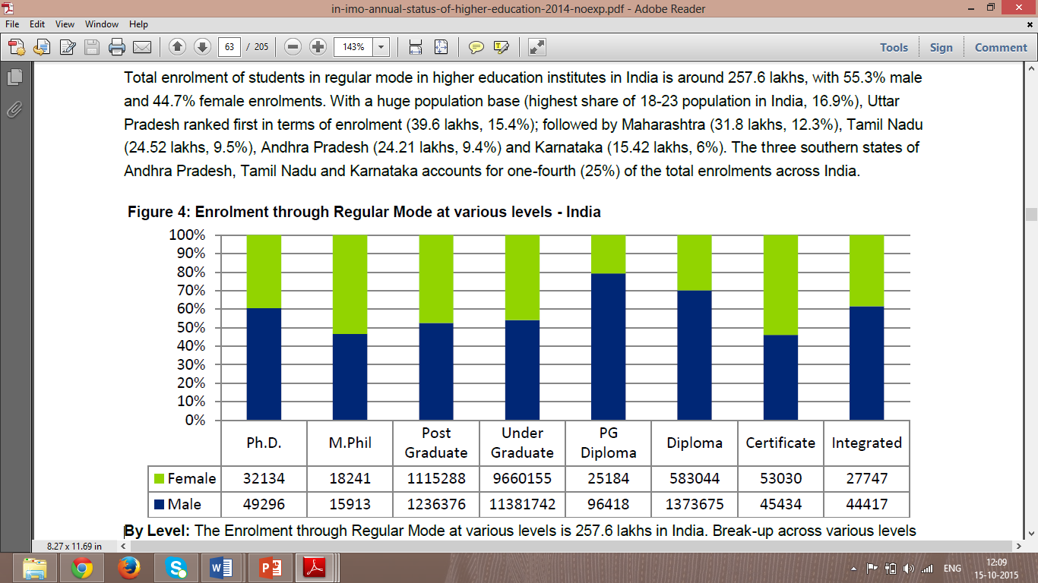Total enrolment of students in regular mode in higher education institutes in India is around 257.6 lakhs, with 55.3% male and 44.7% female enrolments. With a huge population base (highest share of 18-23 population in India, 16.9%), Uttar Pradesh ranked first in terms of enrolment (39.6 lakhs, 15.4%); followed by Maharashtra (31.8 lakhs, 12.3%), Tamil Nadu (24.52 lakhs, 9.5%), Andhra Pradesh (24.21 lakhs, 9.4%) and Karnataka (15.42 lakhs, 6%). The three southern states of Andhra Pradesh, Tamil Nadu and Karnataka accounts for one-fourth (25%) of the total enrolments.

Figure 7: Student enrolment through regular mode at various levels[21]

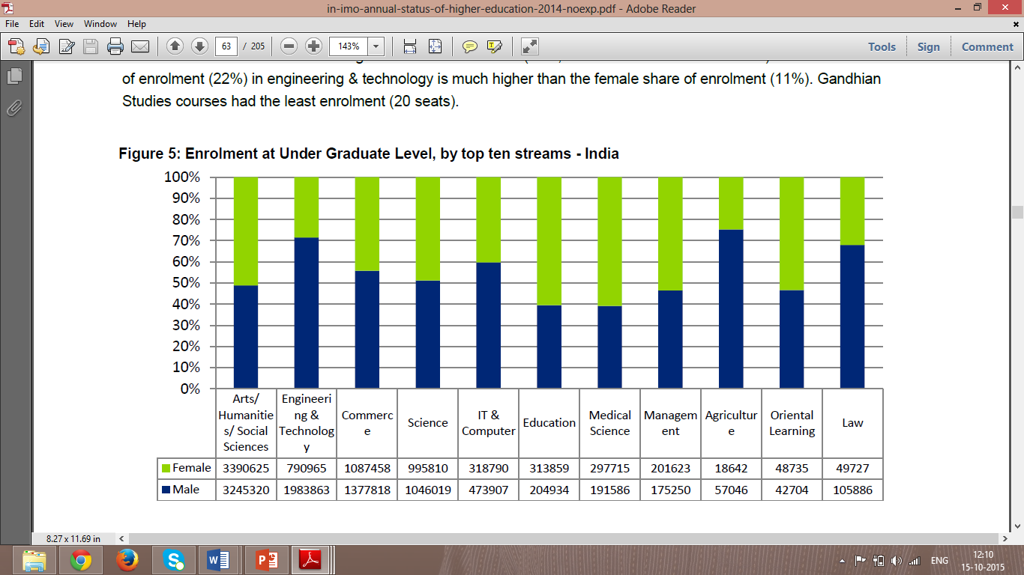

Figure 8: Student enrolment in top ten streams[22]

**By Level:**The Enrolment through Regular Mode at various levels is 257.6 lakhs in India. Break-up across various levels and split by gender is given in the figure / table below. As can be inferred, the highest share of enrolment (81.7%) is at under-graduate level, followed by post-graduate (9.1%) and Diploma (7.6%), with all other levels forming only 1.6%. As can be seen from table above, share of enrolment is almost equal in private unaided and government colleges in the country with 38.3% and 37.9% respectively.

**By Stream:**The total enrolment at under graduate level for the top ten streams (in terms of enrolment) is presented in the figure below. Arts/Humanities/Social Sciences tops the list with 40% enrolment, followed by Engineering & Technology (16.6%). It is interesting to note that female share of enrolment (47%, as a % of total female enrolment) in arts/humanities/social sciences is higher than the male share (36%, as a % of total male enrolment) while the male share of enrolment (22%) in engineering & technology is much higher than the female share of enrolment (11%).

We have understood the scenario all over India and now let us focus on the facts of state from which the selected universities belong. Tamil Nadu is rated the number 1 in India with many private and state universities. Below are the images with figures for the reader’s reference.

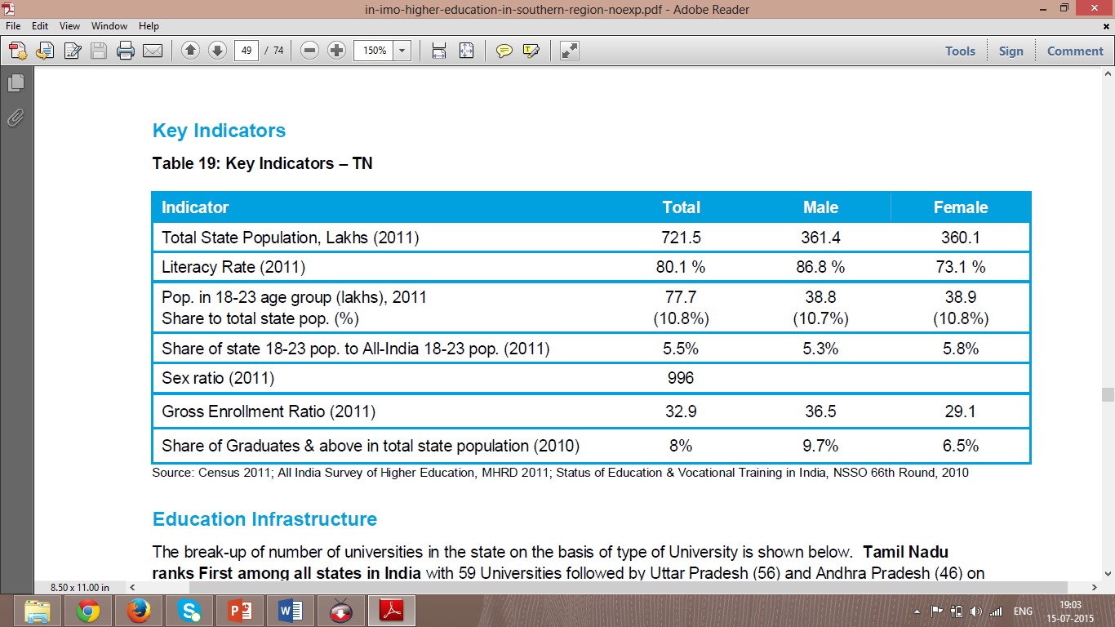

Figure 9: Key indicators Tamil Nadu[23]

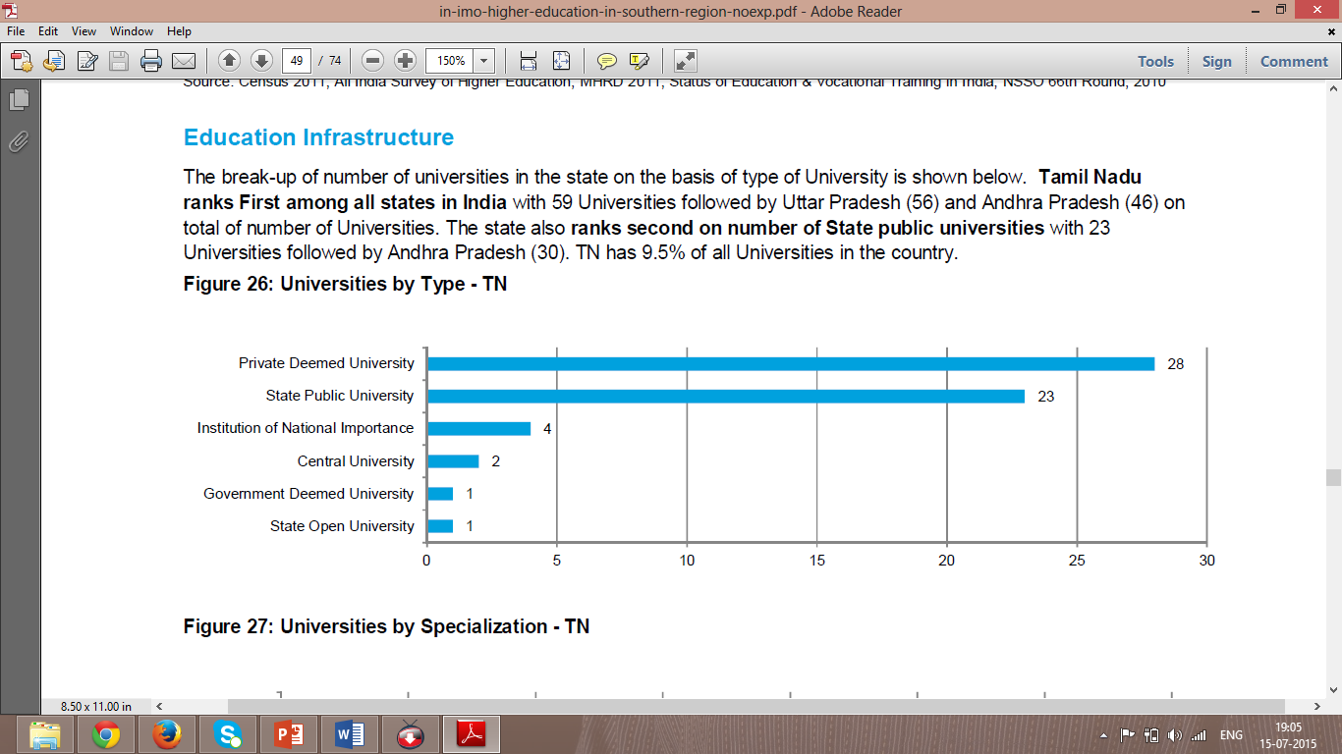

Figure 10: Division of universities in Tamil Nadu[24]

Tamil Nadu with 1,985 colleges has a share of 6.02% of all colleges in India and ranks 7 in terms of total colleges in any state in India. Tamil Nadu has average access with 27 colleges per lakh population as compared to the all India average of 23 colleges per lakh population. However in comparison to major states this number could still be improved. In terms of average enrolment per college, TN (574) is significantly lesser than all India average of 700. Total enrolment of students in regular mode in higher education institutes in TN is around 18 lakhs. Out of the total colleges in the state, 93% are affiliated to Universities, and the remaining are constituent/university colleges, PG/off campus or recognized centres by the Universities. In terms of management, TN colleges are dominated by the Private Unaided colleges, forming 88.5% of all colleges in the state, followed by 5.8% owned by Government and 5.6% that are private aided.

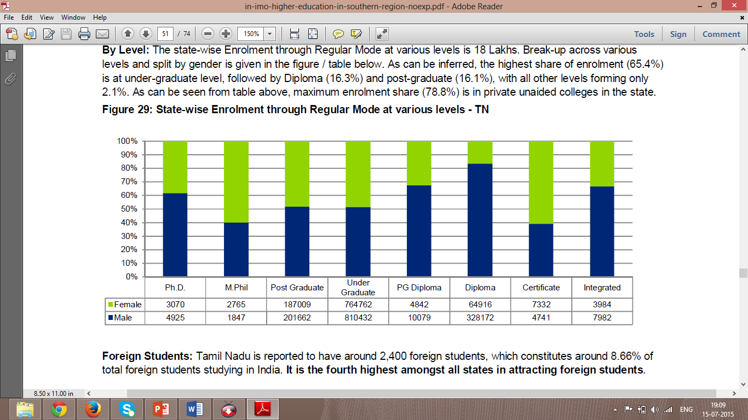

Figure 11: Student enrolment ratio in Tamil Nadu through regular mode at various level[25]

**By Level:** The state-wise Enrolment through Regular Mode at various levels is 18 Lakhs. Break-up across various levels and split by gender is given in the figure / table below. As can be inferred, the highest share of enrolment (65.4%) is at under-graduate level, followed by Diploma (16.3%) and post-graduate (16.1%), with all other levels forming only 2.1%. As can be seen from table above, maximum enrolment share (78.8%) is in private unaided colleges in the state.

2.4 Challenges faced by the sector

While there has been a significant development in the field of higher education in India, it still lags behind in comparison to many developed countries. In fact developing countries like China, Malaysia and South Korea fare better than India on many counts. The situation gets compounded as India has a daunting task of providing employment opportunities to its growing workforce, which can only be possible if it has a sound higher education system. The following table highlights the key issues facing the higher education sector in India.

|  |  |
| --- | --- |
| **Access**  • Low enrolment rates in higher education with GERof 19.4 at the higher education stage (18-23 years)  • GER significantly less than in countries such as US(89), Russia (76), UK (59), Malaysia (40), China(24) | **Equity**  • Gender disparities in higher education (GER of 17.1for males and 12.7 for females in 2009-10)  • Social inequities in access to higher education (GERof 12.2 for SCs and 9.7 for STs in 2009-10) |
| **Quality**  • Significant levels of faculty vacancies in institutes and quality concerns  • Varying quality of education provided in institutes and low level of accreditation  • Limited motivation for learning due to evaluationprocess in colleges  • Inadequate focus on research in higher education  • Lack of adequate infrastructure and equipment  • Low employability and skills of graduates | **Governance and Financing**  • Issues in universities arising from affiliation resultingin administrative burden on universities  • Governance issues in universities such as lack of appropriate structures and limited autonomy  • Financial constraints in higher education, particularlyfor state level institutions  • Lack of clear regulatory framework for private sectorparticipation in higher education |

Table 1: Key challenges in the education field

**Low enrolment rates**

The GER in higher education at 19.4% leaves a vast proportion of eligible population out of the system. The Indian GER is significantly less than comparable figures in other developed and emerging nations such as the USA (89), Russia (76), the United Kingdom (59), Malaysia (40) and China (24)16. While the central government has set a target of achieving a GER of 30% by 2020, it would require massive efforts in terms of strengthening and creating the infrastructure, human resources and other required inputs. While public expenditure on higher education has to go up, the role of private sector would also be critical to achieve the stated targets. Corporate Social Responsibility (CSR) provisions introduced in the new Companies Act 2013 provide an opportunity for private sector participation, which should be suitably leveraged.

**Regional disparities**

There are significant regional variations in enrolments in higher education across the country, which has been duly highlighted in RUSA. For instance, most of the southern states have a high GER, while states like Bihar, West Bengal and Madhya Pradesh have a relatively less GER due to low institutional density. The public expenditure on higher education is also highly uneven amongst states; the states with lower capacities and poorer infrastructure may have to allocate more to catch up to the leading state and the national targets. There is clearly a need to give special focus on states with lower GER in terms of increasing the institutional reach and providing financial assistance to increase spending on higher education.

**Shortage of Faculty**

Faculty shortages and the inability of the educational system to attract and retain well-qualified teachers have been posing challenges to quality education for many years. The number of teachers in the system has not kept pace with the growth in student enrolments and this aspect needs considerable and concerted attention to ensure the sustainability of the higher education system. A study conducted by the National Skill Development Corporation (NSDC)has estimated that there will be incremental requirement of about 31,71,000 teachers in higher education between 2008 and 2022 to ensure a student teacher ratio of 20:1. This is a huge challenge given that this target means a more than three-fold increase in the total number of teachers present in the system currently.

**Concerns over quality of HEIs**

The quality of education imparted to students in the HEIs has been a matter of concern for quite some time. As per the recently released by Times Higher Education Rankings, 2013-14, none of the Indian HEI features on the list of top 200 institutions, which is a reflection of quality of HEIs in the country. A recent study conducted by NASSCOM reveals that only 25% of engineering graduates are readily employable in the IT industry. Further, as per NAAC about 62% of the universities and 90% of the colleges were rated average or below average on specified quality parameters.

**Ambiguity over regulations**

There is a considerable amount of ambiguity with respect to regulations governing higher education. For instance, the applicability of regulations to colleges affiliated to universities, standalone institutions offering certificate, instead of degree/diploma programs, which are of lesser duration as provided for in the AICTE regulations and many more have been a matter of controversy. Similarly, the provisions governing course curriculum, fees, admission tests etc. have resulted in a number of challenges for the existing institutions. These conditions have also acted as a deterrent for genuine education providers from foreign countries to enter the Indian higher education sector.

**Conflict of authority**

Education being on the concurrent list has resulted into a multiplicity of regulators and regulations, which sometimes are in conflict of each other. This state of affairs was highlighted in the Yashpal Committee Report as submitted to the Union Minister Education in 2009. It observed that: “there is very little co-ordination among the statutory bodies in respect of degree durations, approval mechanisms, accreditation processes, etc. It sometimes leads to very embarrassing situations in which we find two regulatory agencies at loggerheads and fighting legal cases against each other.”

**Lack of autonomy**

Higher education in India is often criticised for being over-regulated with regulators exercising control over administrative and operational aspects such as admission policy, duration of programs, eligibility conditions, fixation of fee, salary of teachers, intake capacity, infrastructure requirements etc. These conditions leave virtually no autonomy with individual institutions to offer programs as per global standards through innovative pedagogy.

**Lack of clear-cut policies for private sector participation**

The role of the private sector in higher education is critical as brought out in the preceding sections. This has also been acknowledged by the Working Group for Higher Education constituted for the 12th Five-Year Plan (2012-17) as: “while almost all major committees and policy documents have accepted the need for increased involvement of private sector in higher education, there is also lack of clarity on funding pattern, incentives, and regulatory oversight’. These issues need to be addressed and clarified so as to incentivize the private and corporate sectors to invest in higher education.”

The existing policy on higher education does not provide much clarity on these aspects of private sector participation and a clearer and unambiguous policy direction is essential to encourage a meaningful and effective private sector participation.

To summarize a few challenges faced in the sector- to attract new category of students/customers, increase in academic quality, global education and employability linked education, privatization and globalisation, enhancement in technology driven education. In order to face these challenges, institutes of higher education should identify these challenges and diversify accordingly. For example new modes of delivery, new types of courses, Market relevant approach, Industry linked collaborations, Foreign tie ups etc. [26][27]

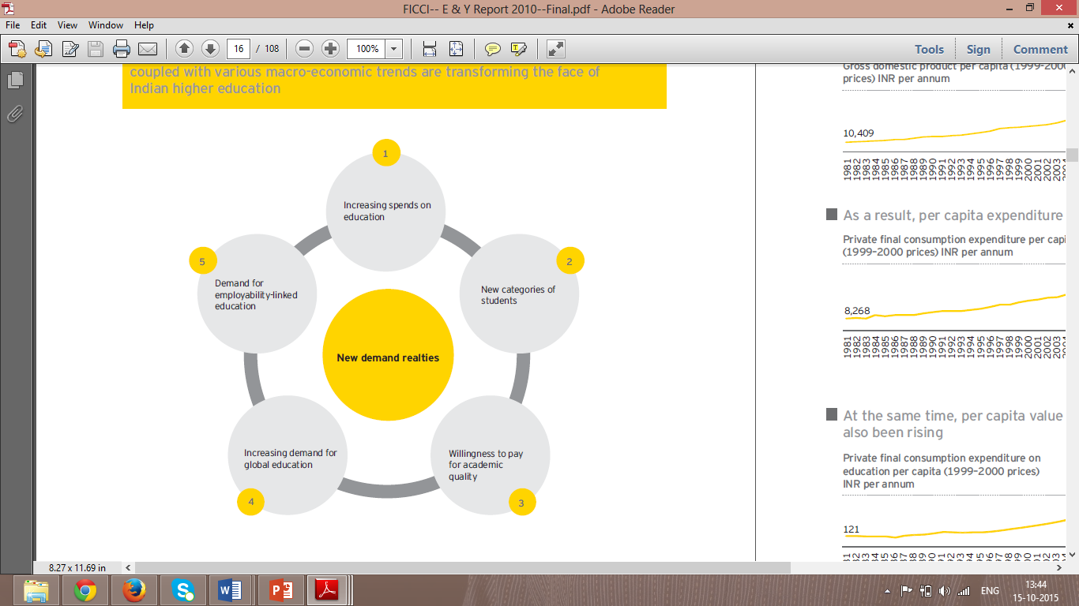

Figure 12: The changing phase of Indian Higher education[28]

3 Analysis of selected universities

3.1 Introduction to selected universities

**Sri ChandrasekharendraSaraswathiViswaMahaVidyalaya**shortly called SCSVMV University or Kanchi University was established in the year 1993 with the divine blessings of Sri JayendraSaraswathiSwamiji.To discover, preserve and transmit the vast knowledge of the Vedas, Sastras, agamas and other traditional arts connected with our culture and civilization. To bring Vedic learning to the status of the University system with a code of syllabus, offering degree programs leading to Ph.D. and to train the students of Sanskrit in contemporary education as well, enabling them to fit into contemporary work situation, should they choose to do so.

Figure 13: Logo of SCSVMV University[29]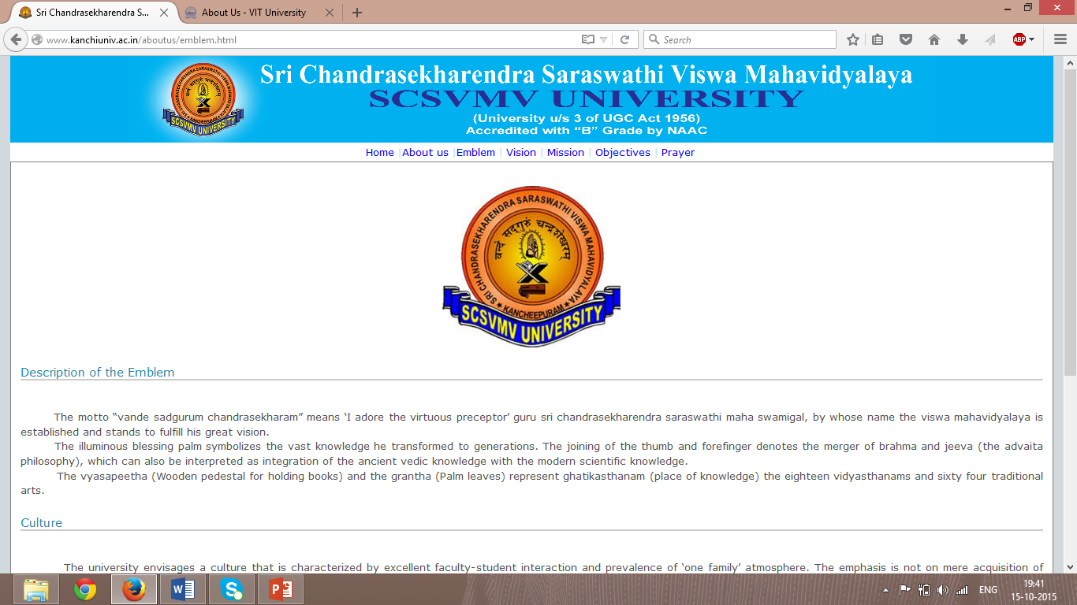

To develop a unique world-class university of higher learning which will conduct teaching and research programs in selected areas of knowledge especially in the Vedic system integrating the higher knowledge imparted by the Vedas with science-based modern knowledge, thereby offering solution to the problems of the modern times and proving the universality and catholicity of the Vedic knowledge and its relevance to the modern times. To create a new generation of scholars who have acquired the skills and competencies for dealing with modern scientific and technological knowledge and integrate such knowledge with Indian ways of thinking and acting. To develop a cadre of world-class professionals, who have acquired the competencies for global employment in different disciplines. To establish special schools of study and research for the revival and re-interpretation of different areas of Indian knowledge like Indian philosophy and culture, Sanskrit language and Linguistics, Indian Arts and Architecture, Indian Science and Technology, Indian Social thought and Epistemology, Indian Social and Institutional Practices thereby making special provisions for offering integrated courses in Vedas, Humanities, Applied Social Sciences and Technology and other allied areas of knowledge in the educational programs of the ViswaMahavidyalaya with the permission of the UGC/MHRD.

To take special measures to facilitate students and teachers from all over India and from other countries as well to join the ViswaMahavidyalaya and participate in its academic programs and to provide instruction and training in such branches of learning as it may deem fit. To offer programs of higher education in the major disciplines, their sub-disciplines and their interacting dimensions to represent major areas of knowledge like Humanities and Languages, Basic and Applied Sciences, Engineering and Technology, Agriculture and Animal Sciences, Indian Medicine, Para-medical Sciences, Management Sciences, Educational Sciences, Behavioral and Cognitive Sciences with due representation given to emerging sub-disciplines like Social Planning and Rural Empowerment, Nano Sciences, Business Logistics and Technology Management, Information and Communication Sciences, Atmospheric Sciences and Climatology and Development Planning in addition to unique programs integrating traditional Sanskrit courses with modern courses such as Ayurveda and conventional medicine; VastuSastra , Architecture, Computer technology, Astronomy, Physics and Mathematics; VimanaSastra, SulbaSastra, Krishi, Vriksha and SilpaSastra combined with the relevant modern subjects such as chemistry, Metallurgy, Engineering, Architecture and Medicine (human, veterinary and plant), Bio-technology, Genetics, ArthaSastra and Business Administration and Education.

To establish collaboration and working partnership with pace-setting higher education institutions in different parts of the world, and use such collaboration for modernizing the operational strategies of this institution. To implement new working modalities for the institution using modern management strategies for system functioning like staff selection and development, curriculum framing, staff and student assessment, system assessment and for ensuring greater social credibility and accountability for the institution. To perform such other functions as may be deemed necessary, conducive or incidental for the achievement of the above objectives.[30]

**Vision-**To provide "quality higher education coupled with Indian Value system and at the same time make it affordable to all sections of the society irrespective of their social or economic standing". It is to identify innate talents of students and bring out their hidden potentialities and help in development of their all-round personality with value systems.[31]

**Mission -** The mission of this university is a holistic approach to higher education with academic standards consistent with an embedded value system, enriched by a dynamic process of synergy. The Mantra is "Educational Delight" of students engaged in study and faculty engaged in teaching and research in their journey towards excellence with creativity. To devise and implement schemes for effectively imparting proficiency in modern technology, at the same time instilling social responsibility and lofty value system enshrined in our culture. To alsomold a new generation of universal citizens with confidence, self-dependence, self-realization, scientific temper, professionalism, thirst for knowledge and contentment by the fusion of Indian thought and modern scientific methodology, in higher education.[32]

**Vellore Institute of Technology**shortly called VIT University was established in the year 1984 by Mr. G. Vishwanath. This university was formerly called Vellore engineering college and later was given the status of a deemed to be university due to its excellent standards of providing education. VIT University was established with the aim of providing quality higher education on par with international standards. It persistently seeks and adopts innovative methods to improve the quality of higher education on a consistent basis. The campus has a cosmopolitan atmosphere with students from all corners of the globe.

Experienced and learned teachers are strongly encouraged to nurture the students. The global standards set at VIT in the field of teaching and research spur us on in our relentless pursuit of excellence. In fact, it has become a way of life for us. The highly motivated youngsters on the campus are a constant source of pride. Our Memoranda of Understanding with various international universities are our major strength. They provide for an exchange of students and faculty and encourage joint research projects for the mutual benefit of these universities. Many of our students, who pursue their research projects in 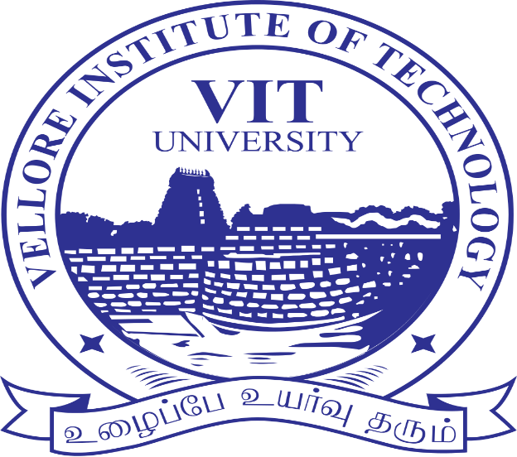foreign universities, bring high quality to their work and esteem to India and have done us proud.

Figure 14: Logo of VIT University[33]

Interesting facts of VIT are that Over 193,000 appeared for the VIT Engineering Entrance Examination (VITEEE) in 2014 and the institution offers 19 Undergraduate, 34 Post graduate, 2 Integrated and 4 Research Programmes. NAAC has re-accredited VIT University with an 'A' grade. A 360-acre eco-friendly campus with over 50.83 lakh square feet built-up space at Vellore and also a 170 acre eco-friendly second campus at Chennai. Over 24,000 students, with nearly 1/3rdof them women along with students from 50 countries as well as from every state in India study at VIT.

**Vision -** We at VIT University will impart futuristic technical education and instill high patterns of discipline through our dedicated staff, who shall set global standards, making our students technologically superior and ethically strong, who in turn shall improve the quality of life of the human race.

**Mission -** Our mission is to educate students from all over India, including those from the local and rural areas, and from other countries, so they become enlightened individuals, improving the living standards of their families, industry and society. We will provide individual attention, world-class quality education and take care of character building.[34]

3.2 Courses offered (Product)

**SCSVMV University** offers education in 7 distinct fields and they are Engineering and Technology, Sanskrit and Indian Culture, Management,Human Resource and Commerce, Arts and Science, Health Science, Science and Education. Since our major focus is in the field of Engineering and Technology. The courses offered are – Mechanical Engineering, Civil and Structural Engineering, Mechatronics Engineering, Electronics and Communication Engineering, Electrical and Electronics Engineering, Computer Science and Engineering, Information Technology, Electronics and Instrumentation Engineering. Most preferred courses by the students of this university are Electronics and Communication and Mechanical which has the highest strength of students (approximately 200). The other courses are would have approximately 100 to 120 students of less. This university follows semester pattern. Each academic year has 2 semesters and the grading system is based on credits given for each subject totaled to 10 cumulative grade points.[35]

**VIT University** follows semester pattern. An academic year consists of two semesters. The fall (odd) Semester begins in June and the winter (even) Semester in December. The academic schedule mentioned in the academic calendar will be strictly followed.  
Qualified faculty members assigned with various theory subjects prepare course plans using the standard format provided by the institute with emphasis on 'learning' of the students. The instructional or lecture delivery of the faculty will be through a set of Educational Technology / Tools opted by the faculty. The lectures lay emphasis on the following- Knowledge content (topics in the curriculum), utility value - application in real life and latest developments.

School of Advanced Sciences, School of Architecture, School of Bio Sciences and Technology, School of Computing Science and Engineering, School of Electrical Engineering, School of Electronics Engineering, School of Information Technology and Engineering, School of Mechanical and Building Sciences, School of Social Science and Languages and VIT Business School are the various schools of education provided at VIT University. As the major focus still lies in the field of engineering and technology, we shall look into the engineering courses offered in various schools at VIT.

The courses offered in Engineering are - Biomedical Engineering, Biotechnology, Computer Science and Engineering, Bio-informatics, Electrical and Electronics Engineering, Electronics and Instrumentation Engineering, Electronics and Communication Engineering, Information Technology, Mechanical Engineering, Civil Engineering, Automotive Engineering and Energy Engineering. Major choices of students are Mechanical and Electronics where almost 1000 students are a part of the course. The rest will accommodate around 700 students.[36]

3.3 Fee structure (Price)

|  |  |  |
| --- | --- | --- |
| **Sl.no** | **Courses offered in engineering** | **Fee** |
| 1 | Computer science | Rs 54,625/semester |
| 2 | Mechanical | Rs 56,500/semester |
| 3 | Civil and structural | Rs 52,125/semester |
| 4 | Electrical and electronics | Rs 52,125/semester |
| 5 | Electronics and communication | Rs 56,500/semester |
| 6 | Information technology | Rs 52,125/semester |
| 7 | Electronics and instrumentation | Rs 52,125/semester |

Table 2: Fee structure of SCSVMV University[37]

|  |  |  |
| --- | --- | --- |
| **Sl.no** | **Courses offered in engineering** | **Fee** |
| 1 | Computer science | Rs 81,500/semester |
| 2 | Mechanical | Rs 81,500/semester |
| 3 | Civil | Rs 81,500/semester |
| 4 | Electrical and electronics | Rs 81,500/semester |
| 5 | Electronics and communication | Rs 92,500/semester |
| 6 | Information technology | Rs 81,500/semester |
| 7 | Electronics and instrumentation | Rs 81,500/semester |
| 8 | Biotechnology | Rs 81,500/semester |
| 9 | Biomedical | Rs 81,500/semester |
| 10 | Chemical | Rs 81,500/semester |
| 11 | Production and industrial | Rs 81,500/semester |
| 12 | Energy , Automotive, Bio-informatics | Rs 92,500/semester |

Table 3: Fee structure of VIT University[38]

3.4 Location (Place)

SCSVMV University is located in a sprawling campus of 50 acres in Kanchipuram, a small semi urban place in the state of Tamil Nadu. It is located 75 km away from the capital as is known as the most happening areas in automobile industry. The city covers an area of 11.605 km2 (4.481 sq. mi) and has a population of 164,384 in 2011. It is the administrative headquarters of [Kanchipuram district](https://en.wikipedia.org/wiki/Kanchipuram_District). It is also well-connected by road and rail. [Chennai International Airport](https://en.wikipedia.org/wiki/Chennai_International_Airport) is the nearest domestic and international airport to the city, which is located at [Tirusulam](https://en.wikipedia.org/wiki/Tirusulam) in [Kanchipuram district](https://en.wikipedia.org/wiki/Kanchipuram_district).

Located on the banks of the [Vegavathy River](https://en.wikipedia.org/w/index.php?title=Vegavathy_River&action=edit&redlink=1), Kanchipuram has been ruled by the [Pallavas](https://en.wikipedia.org/wiki/Pallavas), the [Medieval Cholas](https://en.wikipedia.org/wiki/Medieval_Cholas), the [Later Cholas](https://en.wikipedia.org/wiki/Later_Cholas), the Later Pandyas, the [Vijayanagar Empire](https://en.wikipedia.org/wiki/Vijayanagar_Empire), the [Carnatic kingdom](https://en.wikipedia.org/wiki/Nawab_of_the_Carnatic), and the [British](https://en.wikipedia.org/wiki/British_Raj). The city's historical monuments include the [Kailasanathar Temple](https://en.wikipedia.org/wiki/Kanchi_Kailasanathar_Temple) and the [VaikuntaPerumal Temple](https://en.wikipedia.org/wiki/Tiru_Parameswara_Vinnagaram). Historically, Kanchipuram was a centre of education and was known as the “***Ghatikasthanam****”*, or "place of learning". The city was also a religious centre of advanced education for [Jainism](https://en.wikipedia.org/wiki/Jainism) and [Buddhism](https://en.wikipedia.org/wiki/Buddhism) between the 1st and 5th centuries. In Hindu theology, Kanchipuram is one of the seven Indian cities to reach final attainment. The city houses [VaradharajaPerumal Temple](https://en.wikipedia.org/wiki/Varadharaja_Perumal_Temple), [Ekambareswarar Temple](https://en.wikipedia.org/wiki/Ekambareswarar_Temple), [Kamakshi Amman Temple](https://en.wikipedia.org/wiki/Kamakshi_Amman_Temple), and [Kumarakottam Temple](https://en.wikipedia.org/wiki/Kumarakottam_Temple), which are some of major Hindu temples in the state. The city is a holy pilgrimage site for both [Saivites](https://en.wikipedia.org/wiki/Saivites) and [Vaishnavites](https://en.wikipedia.org/wiki/Vaishnavites). Of the 108 holy temples of the Hindu god [Vishnu](https://en.wikipedia.org/wiki/Vishnu), 14 are located in Kanchipuram. The city is well known for its hand woven silk [sarees](https://en.wikipedia.org/wiki/Sari) and most of the city's workforce is involved in the weaving industry. [39]

Kanchipuram is administered by a Special grade municipality constituted in 1947. It is the headquarters of the [Kanchimatha](https://en.wikipedia.org/wiki/Kanchi_matha), a Hindu monastic institution believed to have been founded by the Hindu saint and commentator [AdiSankaracharya](https://en.wikipedia.org/wiki/Adi_Sankaracharya), and was the capital city of the [Pallava Kingdom](https://en.wikipedia.org/wiki/Pallava_Dynasty) between the 4th and 9th centuries.[40]

Apart from the place at which the university is located, the students can reach the university by bus or auto rickshaw. The students can also avail applications from the website or they can buy personally from the university campus. These are the only two options available for getting an application. The possible ways of paying the fee is through online or direct cash.[41]

VIT University is located in a sprawling campus of 360 acres sitting majestically in Vellore, a semi urban area located in Tamil Nadu. The city of Vellore is approximately 140 km from the capital “Chennai”. Located on the banks of [Palar River](https://en.wikipedia.org/wiki/Palar_River) in the north-eastern part of [Tamil Nadu](https://en.wikipedia.org/wiki/Tamil_Nadu) and has been ruled, at different times, by the [Pallavas](https://en.wikipedia.org/wiki/Pallavas), [Medieval Cholas](https://en.wikipedia.org/wiki/Medieval_Cholas), [Later Cholas](https://en.wikipedia.org/wiki/Later_Cholas), [Vijayanagar Empire](https://en.wikipedia.org/wiki/Vijayanagar_Empire), [Rashtrakutas](https://en.wikipedia.org/wiki/Rashtrakutas), [Carnatic kingdom](https://en.wikipedia.org/wiki/Nawab_of_the_Carnatic), and the [British](https://en.wikipedia.org/wiki/British_Raj). Vellore has four zones (totally 60 wards) which covers an area of 87.915 sq.km and has a population of 423,425 based on 2011 census. Vellore is administered by a [Vellore Municipal Corporation](https://en.wikipedia.org/wiki/Vellore_Municipal_Corporation) under a [mayor](https://en.wikipedia.org/wiki/Mayor).

Vellore region is the top exporter of finished [leather](https://en.wikipedia.org/wiki/Leather) goods in the country. Vellore leather accounts for more than 37% of the country's export of leather and leather-related products. Vellore is also home to several manufacturing and automobile companies such as [Bharat Heavy Electricals Limited](https://en.wikipedia.org/wiki/Bharat_Heavy_Electricals_Limited), [MRF Limited](https://en.wikipedia.org/wiki/MRF_Limited), TVS-Brakes India, [Tamil Nadu Industrial Explosives Limited](https://en.wikipedia.org/wiki/Tamil_Nadu_Industrial_Explosives_Limited) etc.[42]

Apart from the information on the city, the university is also located in the centre of the city and is easily reachable by all means of transport. The applications for the university are available on the website, university campus, post offices and banks, agency/consultancy and university offices at various states and countries all over the world. Various possible ways of paying fee is online and through cash.[43]

3.5 Promotion

**SCSVMV University** promotes itself through various channels like television advertisement (local channels), radio channels (local), paper advertisement (local, regional and national) and social media (twitter, Facebook etc.). Apart from advertisements they also do social activities to publicise themselves. Some of the activities are NSS, yoga, health awareness programs and so on. National level technical, cultural and sports fests are also a part of their promotional activities every year. Below mentioned is a sample of paper advertisement of this university.

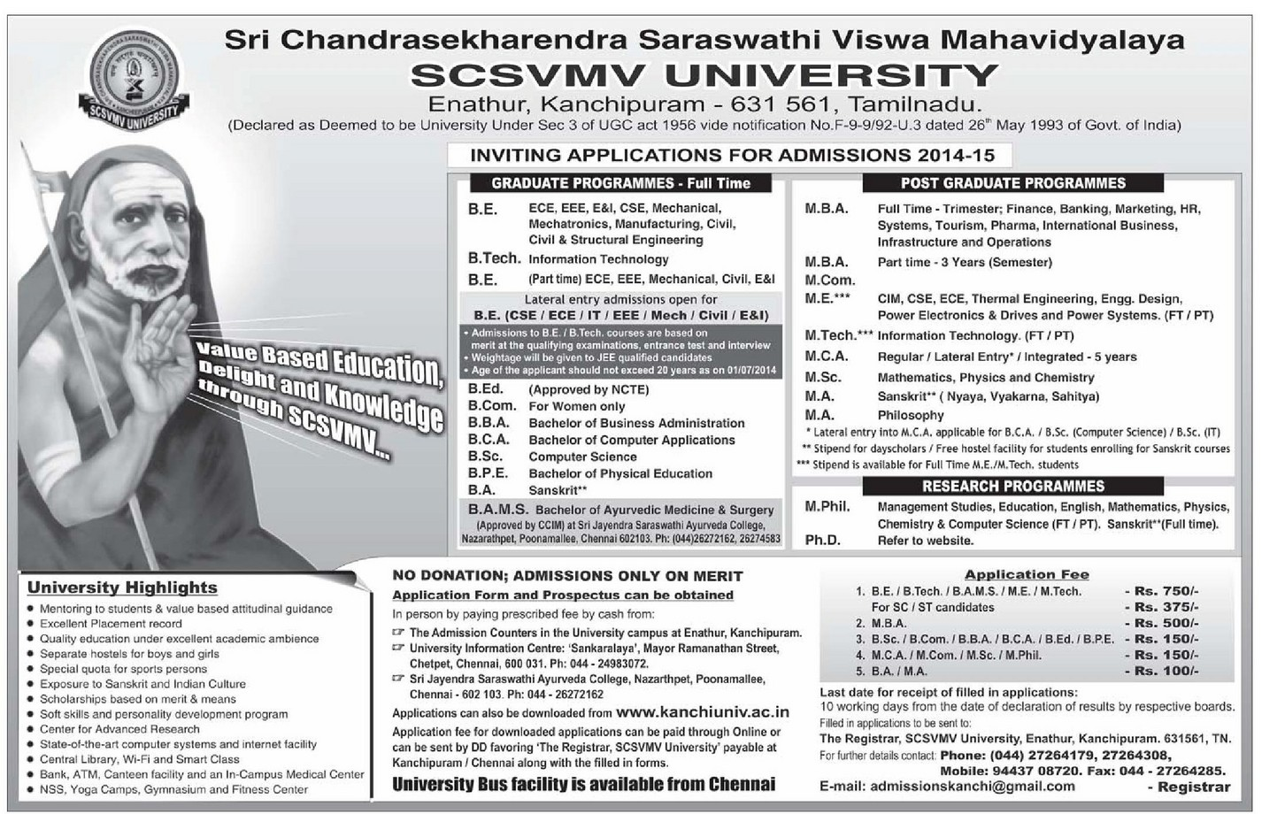

Figure 15: Paper advertisement of SCSVMV University[44]

VIT University promotes itself through various channels like television advertisement (local, regional, national and international), radio channels (local, regional, national and international), paper advertisement (local, regional and national and international), social media (twitter, Facebook, LinkedIn etc.) and magazines (national and international). Apart from advertisements they also do social activities to publicise themselves. Some of the activities are NSS, development and maintenance of roads and bus stands, village adoption programs, disaster response programs, free seats to rank holders of district and economically backward students etc., write ups in newspapers, alumni meets, cultural and technical fests (national and international) and so on. Many goodies with the brand name VIT are also a part of promotional activities done at this university.

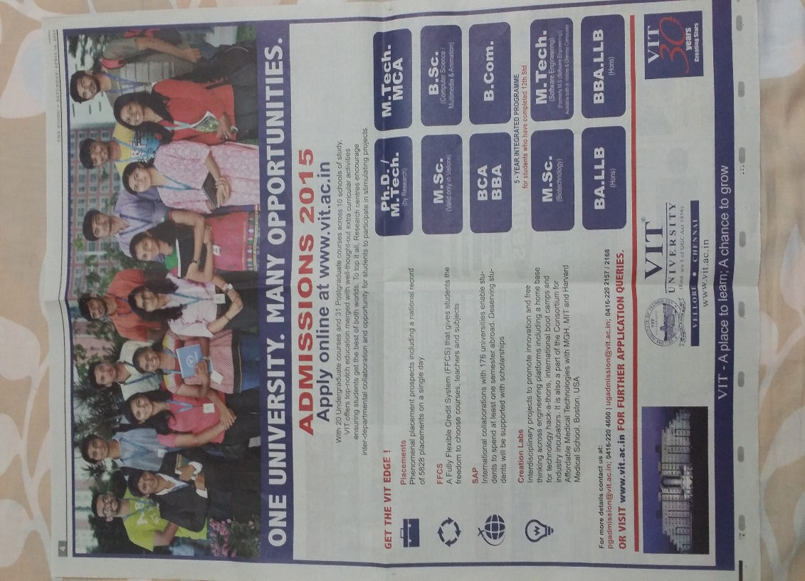

Figure 16: Paper advertisement of VIT University[45]

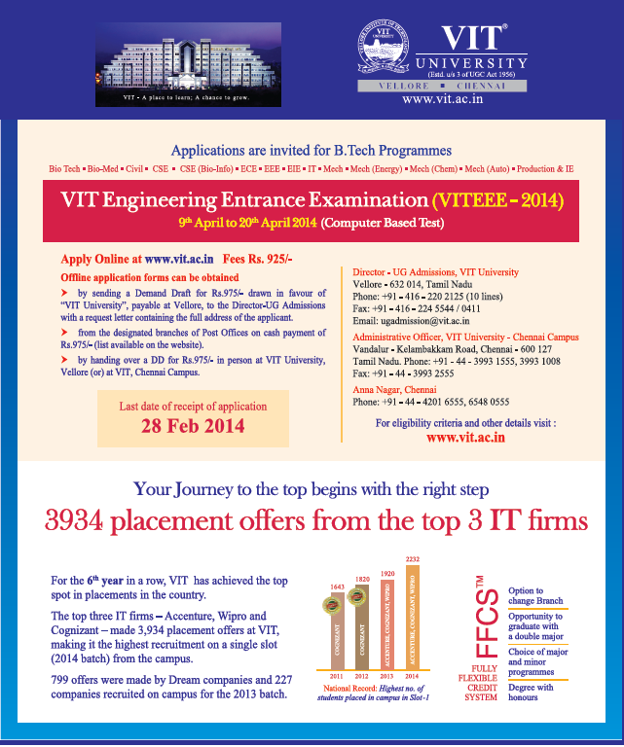

Figure 17: Paper advertisement of VIT University[46]

4 Comparative analysis of Branding

A brand according to dictionary meaning is a trademark or a distinctive name identifying a product, manufacturer, organization. Brand is also defined as a place a product occupies in the mind-sets of people. In short brand is sum of all available information about a product. Brand conveys information in two ways, the first one is through direct experience with the product and the second one is through emotional experience with the product. First information gives functional satisfaction and the later gives emotional satisfaction. Brand in a way fulfils the expectations of individual needs and there by an individual develops bonding with that. A brand reaches people by various communication drivers like advertising, public relations, name, logo, packaging, offers and the environment it offers. It may also fulfil individual needs, family needs, societal needs, physical needs and emotional needs.

4.1 Branding of universities

|  |  |  |
| --- | --- | --- |
| **S.no** | **University 1** | **University 2** |
| Name | SCSVMV | VIT |
| Logo |  | https://upload.wikimedia.org/wikipedia/en/thumb/6/6c/Vellore_Institute_of_Technology_seal.svg/970px-Vellore_Institute_of_Technology_seal.svg.png |
| Caption | Adds value to life and learning | A place to learn, a chance to grow |
| Vision | To provide "**quality** higher education coupled with Indian **Value system** and at the same time make it **affordable** to **all sections of the society** irrespective of their social or economic standing".  It is to identify innate talents of students and bring out their hidden potentialities and help in **development of their all-round personality** with value systems. | We at VIT University will impart **futuristic technical education** and instil high patterns of **discipline** through our dedicated staff, who shall set **global standards**, making our students **technologically superior** and **ethically strong**, who in turn shall improve the quality of life of the human race. |

Table 4: Branding of universities (SCSVMV and VIT)[47]

4.2 Promises made by the universities

|  |  |  |
| --- | --- | --- |
| **S.no** | **University 1[48]** | **University 2[49]** |
| 1 | Value based education | Futuristic Technical Education |
| 2 | No donation, no capitation | Value for money |
| 3 | Affordable cost | Affordable cost |
| 4 | Merit scholarships | Varieties of scholarships |
| 5 | Sanskrit and Indian culture | Ethically strong |
| 6 | Good placements | 100% placements |
| 7 | Experienced Faculty | Experienced Faculty |
| 8 | Separate hostels for boys and girls | Separate hostels for boys and girls according to taste and affordability |
| 9 | Good infrastructure | Modern campus and world class infrastructure |
| 10 | Central library | International library |
| 11 | Accredited university | Accredited university |
| 12 | Good extra – curricular opportunity | Foreign tie ups |
| 13 | 50 acres | 360 acres |
| 14 | Established in 1987 and deemed status in 1993 | Established in 1984 and deemed status in 2000 |
| 15[50] | All India ranking: 18 | All India ranking: 3 |

Table 5: Promises made by both the universities[51]

From the above table, we can observe the different promises made by the universities to attract students. These promises are the promotional facts which the universities use to get students and make profit.

4.3 Expectations of the students**[52]**

|  |  |  |
| --- | --- | --- |
| **S.No** | **University 1** | **University 2** |
| 1 | Brand | Brand |
| 2 | Reputation | Reputation |
| 3 | Excellent placement record | Excellent placement record |
| 4 | Infrastructure | Infrastructure |
| 5 | Training and development | Training and development |
| 6 | Accreditation | Accreditation |
| 7 | Foreign university tie ups | Foreign university tie ups |
| 8 | Experienced faculty | Experienced faculty |
| 9 | Social status | Social status |
| 10 | Scholarships | Scholarships |
| 11 | Extra-curricular activity | Extra-curricular activity |
| 12 | Location | Location |
| 13 | Food court | Food court |
| 14 | Wi fi | Wi fi |
| 15 | Recreational facility | Recreational facility |
| 16 | Personality development classes | Personality development classes |
| 17 | Research facilities | Research facilities |
| 18 | Coaching for competitive exams | Coaching for competitive exams |
| 19 | Industrial visits | Industrial visits |
| 20 | Real time projects | Real time projects |
| 21 | Incubation centres | Incubation centres |
| 22 | Health centres | Health centres |
| 23 | Fee structure | Fee structure |

Table 6: Expectation of students[53]

The students when joining a university will have lot of expectations and would like to find value for the money spent in choosing to study in that particular university. The major focus of this paper is to look into the facts and evaluate the promises made by the university and the student’s expectations and also understand the gap between them. This gap is the scenario where the difference in a good performing university and a normal university lies. The ideal condition for a performing university is to have a very less or zero gap between the promises made and the reality and also to meet the students expectations. This in turn should also provide maximum value for the money spent.

4.4 Reality and Gap analysis

4.4.1 Comparison of marketing mix between the two selected universities**[54]**

|  |  |  |  |
| --- | --- | --- | --- |
| **4P’s** | **Parameter** | **University 1** | **University 2** |
| Product | Courses offered | 7 | 14 |
| Food | Veg only | Veg and non – veg |
| Price | Fee structure | ~ 55,000/course/ semester | ~87,000/course/semester |
| Hostel and mess | ~65,000/annum | ~80,000/annum |
| Place | Occupancy | 2-5 persons/room (depending on the size of the rooms) | 1-6 persons/ room (choice of student with A/C or Non A/C) |
| Availability of applications | University campus, Education fairs and online | University campus, Online, Education fairs, Agency/Consultancy, Banks/Post offices, emails and University offices in different states and countries. |
| Mode of payment | Online and cash | Online and cash |
| Location | Semi urban | Semi urban |
| Promotion | Advertisement | Newspapers (local, regional and national), social media, Television (local channel), Hoardings/banners/flyers, educational fairs | Newspapers (Local, regional, national and international magazines), Television, Radio, Social Media, Hoardings/banners/flyers, Educational fairs (national and international), Sponsored programs |
| Promotion | CSR & publicity | Health awareness programs, Yoga, NSS, Swach-Bhararth etc., write ups in newspapers, alumni meets, technical and sports meet (national) | Sponsored and maintains roads and bus stops in Vellore, NSS, village adoption programs, disaster response programs, Free seats to rank holders of district and economically backward students etc., write ups in newspapers, alumni meets, cultural and technical fests (national and international) |

Table 7: Comparison of marketing mix between the universities[55]

**Inference:** From the above comparison we have understood that university 2 (VIT) has outperformed university 1 (SCSVMV) in all the aspects of the marketing mix by being more varied in nature and more sophisticated in approach.

4.4.2Factors influencing choice of university

|  |  |  |  |
| --- | --- | --- | --- |
| **S.no** | **Student expectation** | **University 1 (ranks)** | **University 2 (ranks)** |
| 1 | Brand | 8 (67%) | 1 (90%) |
| 2 | Reputation | 3 (82%) | 2 (86%) |
| 3 | Good Placement | 7 (69%) | 3 (84%) |
| 4 | Experienced Faculty | 4 (80%) | 8 (75%) |
| 5 | Infrastructure | 2 (83%) | 6 (78%) |
| 6 | Training & Development | 5 (72%) | 7 (76%) |
| 7 | Accreditation | 6 (70%) | 9 (73%) |
| 8 | Social status | 9 (65%) | 5 (79%) |
| 9 | Influence of parents, friends, relatives etc. | 1 (85%) | 4 (82%) |

Table 8: Factors influencing choice of university (ranks)[56]

**Inference:** Based on the above rankings, influence of parents, friends, relatives etc. was ranked high in choosing university 1 whereas brand was the influencing factor in choosing university 2.

From this inference we can also understand that the major reason for joining university 1 is parents influence. The reason for strong influence of parents is because of the religion aspects because the university is a Brahmin minority university and also this university doesn’t collect any donations. The average salary of a student’s parent in this university is between 2 to 3 lakhs per annum. This university is affordable to this category of people and university 2 (VIT) would be more expensive.[57]

4.4.3 Promises vs Reality

|  |  |  |
| --- | --- | --- |
| **S.no** | **Promises by University 1** | **Reality** |
| 1 | Value based education | Yes |
| 2 | No donation, no capitation | Yes |
| 3 | Affordable cost | Yes |
| 4 | Merit scholarships | Yes |
| 5 | Sanskrit and Indian culture | Yes |
| 6 | Good placements | Partial |
| 7 | Experienced Faculty | Partial |
| 8 | Separate hostels for boys and girls | Yes |
| 9 | Good infrastructure | Partial |
| 10 | Central library | Yes |
| 11 | Accredited university | Yes |
| 12 | Good extra – curricular opportunity | Partial |

Table 9: University 1 promises[58]

|  |  |  |
| --- | --- | --- |
| **S.no** | **Promises by University 2** | **Reality** |
| 1 | Futuristic Technical Education | Yes |
| 2 | Value for money | Yes |
| 3 | Affordable cost | Students are willing to pay premium price |
| 4 | Varieties of scholarships | Yes |
| 5 | Ethically strong | Partial |
| 6 | 100% placements | Yes |
| 7 | Experienced Faculty | Yes |
| 8 | Separate hostels for boys and girls according to taste and affordability | Yes |
| 9 | Modern campus and world class infrastructure | Yes |
| 10 | International library | Yes |
| 11 | Accredited university | Yes |
| 12 | Foreign tie ups | Yes |

Table 10: University 2 promises[59]

To understand the gap between the promises and the reality, the above tables are an example. University 1 was not able to keep up promises as university 2 and hence university 2 is performing better than university1. University 2 has better student attraction strategies.

4.4.4 Students expectation vs Reality

|  |  |  |  |
| --- | --- | --- | --- |
| **S.No** | **Students expectations in University 1** | **Reality** | **Rank** |
| 1 | Brand | Partial | 11 |
| 2 | Reputation | Partial | 6 (74%) |
| 3 | Excellent placement record | Partial | 10 (65%) |
| 4 | Infrastructure | Partial | 5 (75%) |
| 5 | Training and development | Partial | 12 (60%) |
| 6 | Accreditation | Yes | 4 (79%) |
| 7 | Foreign university tie ups | No | - |
| 8 | Experienced faculty | Partial | 7 (72%) |
| 9 | Social status | Partial | 14 (55%) |
| 10 | Scholarships | Yes | 3 (80%) |
| 11 | Extra-curricular activity | Partial | 13 (57%) |
| 12 | Food court | No | - |
| 13 | Wi fi | Yes | 2 (84%) |
| 14 | Recreational facility | Partial | 15 (53%) |
| 15 | Personality development classes | No | - |
| 16 | Research facilities | Yes | 8 (71%) |
| 17 | Coaching for competitive exams | No | - |
| 18 | Industrial visits | Partial | 16 (50%) |
| 19 | Real time projects | No | - |
| 20 | Incubation centres | No | - |
| 21 | Health centres | Yes | 9 (69%) |
| 22 | Fee structure | Affordable | 1 (86%) |

Table 11: Expectation vs. reality in university 1[60]

**Inference:** Students expectation vs reality and their rankings are a mis-match. Whatever the students are expecting out of a university are not properly provided.

|  |  |  |  |
| --- | --- | --- | --- |
| **S.No** | **Students expectations in University 2** | **Reality** | **Rank** |
| 1 | Brand | Yes | 1 (94%) |
| 2 | Reputation | Yes | 2(93%) |
| 3 | Excellent placement record | Yes | 3 (90%) |
| 4 | Infrastructure | Yes | 4 (89%) |
| 5 | Training and development | Yes | 7 (85%) |
| 6 | Accreditation | Yes | 8 (82%) |
| 7 | Foreign university tie ups | Yes | 9 (80%) |
| 8 | Experienced faculty | Yes | 6 (86%) |
| 9 | Social status | Yes | 5 (87%) |
| 10 | Scholarships | Yes | 11 (78%) |
| 11 | Extra-curricular activity | Yes | 13 (76%) |
| 12 | Food court | Yes | 14 (75%) |
| 13 | Wi fi | Yes | 10 (79%) |
| 14 | Recreational facility | Yes | 16 (73%) |
| 15 | Personality development classes | Partial | 21 (60%) |
| 16 | Research facilities | Yes | 15 (74%) |
| 17 | Coaching for competitive exams | Partial | 20 (65%) |
| 18 | Industrial visits | Yes | 17 (70%) |
| 19 | Real time projects | Partial | 19 (67%) |
| 20 | Incubation centres | Yes | 12 (77%) |
| 21 | Health centres | Yes | 18 (69%) |
| 22 | Fee structure | Premium price | Willing to pay |

Table 12: Expectation vs. reality in university 2[61]

**Inference:** Students expectation vs. reality and their rankings are a good match. Whatever the students are expecting out of a university are provided 90%.

4.4.5 Factors influencing decision to pay capitation

University 1 admits students only through merit and university 2 collects capitation based on the course chosen, their background and marks in 12th standard. 43% of students pay capitation as a matter of social status or prestige, 21% of them pay capitation to avail better placements and good infrastructure. 16% of them are ready to pay capitation because of opportunities to go abroad. The remaining pay to avoid peer pressure, good marriage proposal and also exposure to people of high class (people with better income). On an average every students parent will earn around 4-5 lakhs per annumwho admits their heir in university 2 (VIT) and also average education background is post-graduation.[62]

4.5Critical success factors (SWOT)

**Strength: VIT Strength: SCSVMV**

1. Fast growth 1. Values
2. Good financial performance 2. No donation, no capitation
3. Better visibility and reach 3. Discipline
4. Futuristic approach 4. Market relevant syllabus
5. Brand and trendy 5. Affordable cost
6. 100% placements

**Weakness:**

1. Ethical dilemma 1. Less visibility
2. Quality of food 2. Quality of food

3. Weak placement record

4. No foreign tie ups

**Opportunities:**

1. Expansion 1. Scope for improvement

**Threat:**

1. Foreign universities 1. Foreign universities
2. Other universities on same level 2. Local colleges/universities

5 Recommendations (Action plan)

A hypothetical action plan based on the available data has been plotted and when followed it is expected to have a better progress in terms of number of students and expansion. Universities like SCSVMV can follow this action plan to survive and succeed in the sector of dynamic changes.

|  |  |  |  |  |
| --- | --- | --- | --- | --- |
| **Year** | **Product** | **Place** | **Price** | **Promotion** |
| 2016 & 2017 | Awareness and availability of products to be enhanced | Acquire lad for expansion | Existing fee structure to be continued | National television advertisements, sponsored programs, varieties of scholarships, high visibility on newspapers |
| 2018 & 2019 | Introduce futuristic courses | Addition of new infrastructure | Fee structure can be revised | Promote expansion and new courses, more newspaper advertisements and social work |
| 2020 - 2022 | New product introduction and innovation in existing products | Expand to new market segments | Market relevant price | Promote results of increased courses and placements |
| 2023-2025 | Foreign tie ups | Expand to new market segments | Continue with market trend | Alumni meets, cultural and technical fest, education fairs and all the above |

6 Conclusion

India is one of the largest providers of education in the world. There are many institutes of higher education sprouting every day and it has become a huge hub for higher education. Institutions also must look into the fact that the sector is changing dynamically and should adjust and improve accordingly. The universities mentioned above in the research paper are examples of universities who have acclimatized and yet to acclimatize to the change in the market. The only way to earn more profits and expand fast is to reduce the gap between the promises made by the universities and the reality and also to fulfill the student’s expectations to the fullest. On doing so more students would choose to study at the university and are chances for growth and prosperity.

As the saying goes “*You don’t drown by falling in the water, you drown by staying there*”

* Edwin Louis Cole

Change is the only constant in this market. Adjusting and implementing ideas accordingly will lead to a successful path.

Bibliography

#### [Educating a Diverse Nation: Lessons from Minority-Serving Institutions](http://www.hup.harvard.edu/catalog.php?isbn=9780674736801)by Clifton Conrad and Marybeth Gasman

#### How college maintains inequality by Elizabeth A. Armstrong and Laura T. Hamilton

#### Ancient India by AiyangarSakkotaiKrishnaswami

#### Minds online by Michelle D. Miller

#### Education in India – Dynamics of Development byMadhuParhar and MarmarMukhopadhayay

#### Survey of higher education in India 2014

#### History of education by Chandra Gosh

#### www.kanchiuniv.ac.in

#### www.vit.ac.in

#### Vellore Corporation – Government of Tamil Nadu 2011

#### FICCI – E&Y report on higher education 2010

#### Higher education in south India – Deloitte analysis 2013

#### UGC report on higher education 11th plan (2007-2012)

#### Annual status of higher education report – CII analysis

#### Annual status of higher education in states and union territories 2014

#### RUSA national higher education mission document 2013

#### Higher education report – PWC analysis 2013

#### www.ugc.ac.in

#### www.mhrd.gov.in

#### www.aicte-india.org

#### www.education.nic.in

#### www.economictimes.indiatimes.com

#### ww.career360.com

#### www.kabconsultants.com

**Appendix**

**Comparative analysis on critical success factors on branding a university**

**I am undertaking a study on “Comparative analysis on critical success factors on branding a university”**

**I request you to kindly complete this questionnaire; all information collected is for research purpose and shall be treated with utmost confidentiality.**

**Profile of the student**

1. Gender – Male, Female
2. Age – 18, 19, 20, 21, 22, 23
3. Educational qualification – B.E/B.TECH, M.E/M.TECH
4. Where is your University located? – Rural, Semi-urban, Metro, City
5. Did the location factor influence your decision? – Yes, No
6. No of students in the organisation? - <250, 250-500, 500-1000, >1000

**Student Awareness and related factors**

1. How did you come to know of your university? (Can select more than one option)
   1. Reference from an existing student
   2. Reference from a teacher from your previous school
   3. Relatives
   4. Friends
   5. Agency/consultancy
   6. Media
   7. Social media
   8. All the above
   9. None of the above
2. What are the reasons for choosing your present university for your studies? (can select more than one option)
   1. Brand
   2. Reputation
   3. Good excellent placement record
   4. Experienced faculty
   5. Infrastructure
   6. Training and development
   7. Accreditation
   8. Foreign university collaboration
   9. Extra-curricular opportunity
   10. Influence of parents
   11. Social status
   12. All the above
   13. None of the above
   14. Others (please specify)
3. How according to you does the role of parents, relatives, friends, neighbours etc. influence your decision on selecting a university?
   1. Very high
   2. High
   3. Neutral
   4. Low
   5. Very low
4. Who or what influenced your decision? (can select more than one option)
   1. Parents
   2. Friends
   3. Relatives
   4. Financial status
   5. Prestige
   6. No influence
5. Income of parents/annum
   1. <2 lakhs
   2. 2-3 lakhs
   3. 3-4 lakhs
   4. >4 lakhs
6. Education level of parents (Either father or mother or both)
   1. 10th
   2. 12th
   3. Graduate
   4. Post Graduate
   5. Doctorate

**Exception vs Reality**

1. After joining the university, what is your opinion on your expectations versus reality on the following factors?
   1. Placements – least effective, less effective, neutral, effective, highly effective
   2. Faculty - least effective, less effective, neutral, effective, highly effective
   3. Infrastructure - least effective, less effective, neutral, effective, highly effective
   4. Administration - least effective, less effective, neutral, effective, highly effective
   5. Hostels - least effective, less effective, neutral, effective, highly effective
   6. Foreign tie ups - least effective, less effective, neutral, effective, highly effective
   7. Extra-curricular opportunity - least effective, less effective, neutral, effective, highly effective
   8. Social acceptance - least effective, less effective, neutral, effective, highly effective
   9. Student clubs - least effective, less effective, neutral, effective, highly effective

**Promotion strategy employed**

1. What is your opinion on the student attraction program of your present university
   1. Effective
   2. Neutral
   3. Ineffective
2. What is your opinion on the promotion strategies employed by your university?
   1. Television advertisement – very bad, bad, neutral, good, very good
   2. Social media – very bad, bad, neutral, good, very good
   3. Paper advertisement – very bad, bad, neutral, good, very good
   4. College website – very bad, bad, neutral, good, very good
   5. Banners/flyers/posters – very bad, bad, neutral, good, very good
   6. Education fair – very bad, bad, neutral, good, very good

**Student investment and influencing factors**

1. Capitation/premium paid?
2. What according to you is the reason behind paying donation to acquire admission in the university? (can select more than one option)
   1. Prestige
   2. Peer pressure
   3. Better placements
   4. Good infrastructure
   5. Opportunity to go abroad
   6. Good knowledge exposure
   7. Good marriage proposal
   8. Interaction and relationship with upper class people
   9. All of the above
   10. None of the above
   11. Others (please specify)
3. Your opinion on the tuition fee based on income level of parents
   1. High
   2. Moderate
   3. Low
4. Source of tuition fee
   1. Student loan
   2. Parents
   3. Private finance
5. Your opinion on the tuition fee in relation to the same courses in other universities
   1. High
   2. Moderate
   3. Low
6. Is there any fee reduction policy in your university? (If the answer is yes, kindly answer the next question also) – Yes, No
7. If Yes, What is the mode of fee reduction?
   1. Merit
   2. Reservation
   3. Financial background
   4. Disability
   5. Scholarships
   6. Others (please specify)
8. Payment mode of tuition fee
   1. Advance payment
   2. Cash
   3. Cheque
   4. Demand draft
   5. Online payment
   6. Others (please specify)

1. http://vivekananda.hubpages.com/hub/How_the_Gururkul_System_of_Education_can_make_a_difference
2. History of educationby Suresh Chandra Ghosh (Pg no 17-20)
3. https://www2.deloitte.com/content/dam/Deloitte/in/Documents/IMO/in-imo-higher-education-in-southern-region-noexp.pdf
4. FICCI – E&Y report on higher education 2010
5. https://www2.deloitte.com/content/dam/Deloitte/in/Documents/IMO/in-imo-higher-education-in-southern-region-noexp.pdf
6. https://www.pwc.in/en_IN/in/assets/pdfs/industries/education/publication/higher-education-report-nov-2012.pdf
7. http://www.ugc.ac.in/stateuniversitylist.aspx?id=1&Unitype=2
8. http://www.ugc.ac.in/stateuniversitylist.aspx?id=1&Unitype=2
9. http://mhrd.gov.in/
10. http://articles.economictimes.indiatimes.com/2006-05-01/news/27424899_1_ugc-act-universities-institutes-of-national-importance
11. http://mhrd.gov.in/
12. http://www.aicte-india.org/
13. http://www.aicte-india.org/
14. PWC analysis on Higher education 2014
15. http://mhrd.gov.in/about-mhrd
16. http://www.ugc.ac.in/page/Genesis.aspx
17. http://www.education.nic.in/tech/tech_if-nlc.asp
18. UGC report on 'HE in India Strategies during 11th plan (2007-2012) for Universities and Colleges', UGC Report on 'Higher Education at a Glance February 2012', UGC report on 'Inclusive and Qualitative Expansion of Higher Education 12th Five-Year Plan, 2012-17', industry discussions and PwC analysis
19. Annual status of higher education 2014 – CII analysis
20. https://www2.deloitte.com/content/dam/Deloitte/in/Documents/IMO/in-imo-higher-education-in-southern-region-noexp.pdf
21. Annual Status of Higher Education in States and UTs 2014
22. Annual Status of Higher Education in States and UTs 2014
23. Source: https://www2.deloitte.com/content/dam/Deloitte/in/Documents/IMO/in-imo-higher-education-in-southern-region-noexp.pdf
24. Source: https://www2.deloitte.com/content/dam/Deloitte/in/Documents/IMO/in-imo-higher-education-in-southern-region-noexp.pdf
25. Source: https://www2.deloitte.com/content/dam/Deloitte/in/Documents/IMO/in-imo-higher-education-in-southern-region-noexp.pdf
26. UNESCO Institute for Statistics Database
27. Sanjay Dhande Committee on Faculty Shortage and Performance Appraisal System; RashtriyaUchchatarShikshaAbhiyan (RUSA) - National HigherEducation Mission document, MHRD, Sept. 2013.
28. New realities, new possibilities – the changing face of Indian higher education, FICCI and E&Y report 2010
29. http://www.kanchiuniv.ac.in/aboutus/emblem.html
30. http://www.kanchiuniv.ac.in/aboutus/objectives.html
31. http://www.kanchiuniv.ac.in/aboutus/vision.html
32. http://www.kanchiuniv.ac.in/aboutus/mission.html
33. http://www.vit.ac.in/AboutUs/index/1
34. http://www.vit.ac.in/AboutUs/index/1
35. www.kanchiuniv.ac.in
36. www.vit.ac.in
37. www.kanchiuniv.ac.in
38. www.vit.ac.in
39. About city – Government of Tamil Nadu 2011
40. Aiyangar, SakkottaiKrishnaswami (2004). [Ancient India: Collected Essays on the Literary and Political History of](http://books.google.co.in/books?id=htArUg0OMpcC&pg=PA128&dq=kanchipuram+%2B+aiyangar&hl=en&sa=X&ei=BIihUNSZMoTE0AGTx4GACA&ved=0CDgQ6AEwBA#v=onepage&q&f=false)New Delhi: Asian Educational Services.
41. www.kanchiuniv.ac.in
42. Vellore corporation – Government of India 2011
43. www.vit.ac.in
44. http://kabconsultants.com/Notification/3/1392/Sri-Chandrasekharendra-Saraswathi-Viswa-Mahavidyalaya-SCSVMV-University-2014
45. The Hindu education plus – April 18 2015
46. Career 360 magazine
47. www.kanchiuniv.ac.in,www.vit.ac.in
48. www.kanchiuniv.ac.in
49. www.vit.ac.in
50. The week – university rankings 2014
51. Primary data - questionnaire
52. Survey and personal interviews
53. Personal interview and primary data – survey through questionnaire
54. Survey and secondary data
55. Primary data – survey through questionnaire
56. Primary data – survey through questionnaire
57. Personal interviews and primary data through survey
58. Primary data – survey through questionnaire
59. Primary data – survey through questionnaire
60. Primary data - survey through questionnaire and personal interview
61. Primary data - survey through questionnaire and personal interview
62. Primary data - survey through questionnaire and personal interview